Computer Technology: Unit 2 Teacher Resources

Buffy Ann Summers

Goal: To raise awareness of the plight of street dogs in the local village, resulting in action being taken to reduce the numbers humanly and food and shelter for the existing street dogs

Product/ Solution: Video (documentary) on the plight of street dogs, placed on a social media website.

Area of interaction: Community and Service/ Human Ingenuity

Abstract: The goal was to raise awareness of the plight of street dogs in the Kaaragac Koyu village. A series of interviews were conducted with local villagers, the Mayor of the village as well as veterinarians. For the greatest impact, the video produced was about the day in the life of a street dog via the use of a ‘dog cam’. The film, shown at the village hall resulted in the Mayor pledging funds to house the street dogs and local vets reducing the fees for sterilisation to help reduce the numbers.
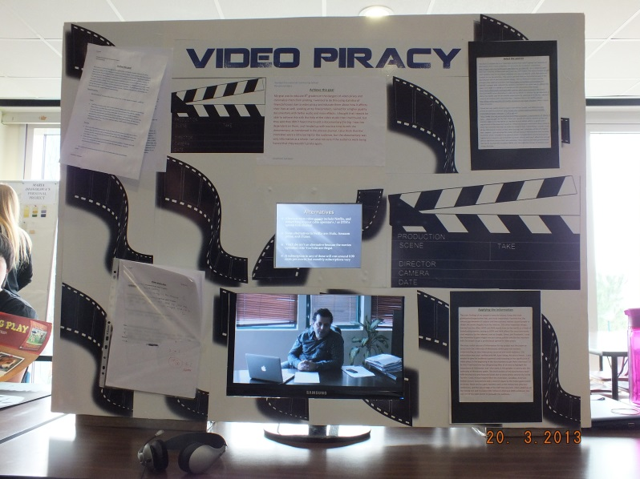

Table of contents

Section | Page
Introduction
A: Investigate
B: Design (Design A, Design B, Evaluation of Designs)
C: Plan (Initial Plan, Final Plan with modifications)
D: Create (Draft 1, Evaluation of Draft 1, Draft 2, Process Journal)
E: Evaluate
Appendix A: Interviews
Appendix B: Surveys before presentation
Appendix C: Surveys after presentation

Introduction

A: Investigate

B: Design

C: Plan

D: Create

E: Evaluate

