PLAN
By: Mayra Eren
Design Technology 3S1

Numbered list of jobs and tools to use | Duration
I will ask the art department which colors they have for the paints that I will be able to use on the material I am choosing. I will accordingly draw my final design. | 10min
I will start drawing my detailed design of my clock. I will draw the outline and then proceed to draw in the details and I will finally color it to make the colors come to life, and I will decide which colors will end up looking proper together. | 45min
I will show Mr. Thorburn my design and wait for approval, if he does not approve of my design I will use some of the extra time that I had put aside to work on a new drawing of my final design. | 10min
I will listen to Mr. Thorburn tell us how the tools are used and what they are used to shape or cut. | 10min
I will figure out which tools I need to use for which materials and look over the tools and materials to be sure.  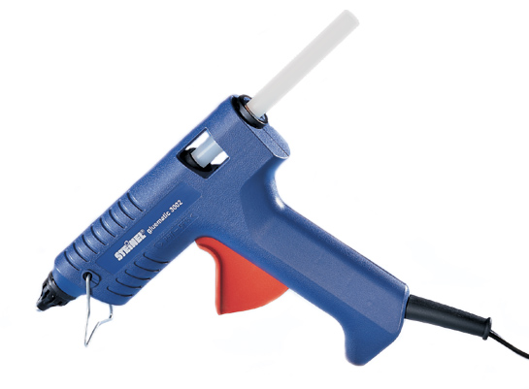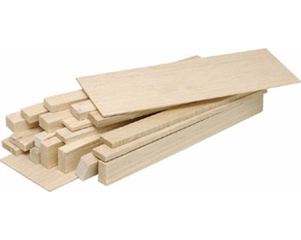 | 10min
I will go pick out my materials and make sure that they are all here. (hot glue gun, balsa wood, ruler, hand saw) | 10min
I will draw a circle onto the piece of wood to mark out how big it is supposed to be, then on top of the roughly marked out circle, using a compass, I will make a proper circle that is exactly round. 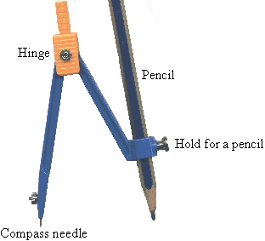 | 10min
I will cut out the circle and this might take me a little longer time since I am not familiar with the tools that are needed to do this. | 15min

I will precisely measure to find the exact center of the circle, there I will create a little hole, using the drill, so that the mechanism can fit thorugh the hole in order for the clock to work. 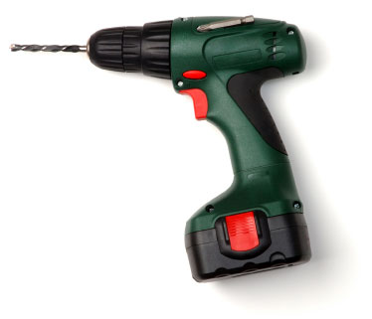 | 10min
Once I have figured out the measurement details I will draw the points where the numbers will go onto the circle which is the base of the clock. Diving the difference between ever number equally. | 5min
I will work on my process journal. I will write down what I have done recently and mostly during this period. | 15min
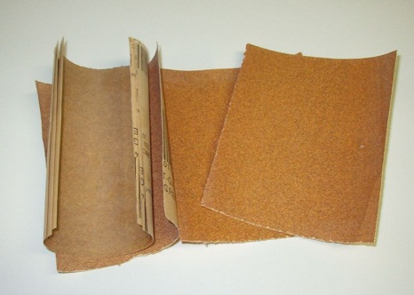  I will take some glass paper and start sanding the outside of the clock, I will also sand inside of the hole I had drilled to make sure that it is smooth. | 5min
I will take a file and smooth the sides of every piece of foam board that I have just cut.  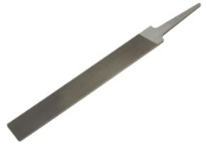 | 10min
I will go up to the art room and paint the base of my clock white. | 5min
While I wait for the paint to dry I will work on my process journal | 10min
I will take a pencil and outline the numbers onto the base of the clock, this will be where I put the numbers onto.  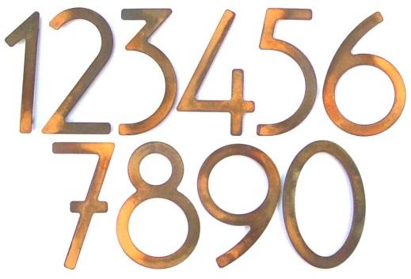 | 15min
I will outline where the circles will go outside the numbers so that they are not blocking each other. | 5-10min
I will start painting the numbers black, I will paint in great detail to be sure that the numbers and legible and look almost perfect. | 15min
I am going to choose the colors of the dots next. Iw ill look at the paints that we have in the art room and decide which colors go best together. 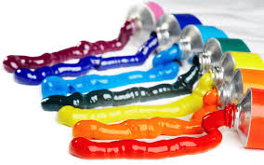 | 10min
I am going to start painting in the circles on the clock. I will make sure that they don’t smudge with the numbers on the clock. I might have to wait for the numbers to dry before. | 15min
I will work on my process journal while waiting for the clock to dry. | 15min
I will make sure that there are no rough edges on the clock, if there are I will quickly sand them to make it smooth and make it look good. | 15min
My clock now needs a frame. I will make the frame out of the same wood. I will take my finished and dried clock, and I will put it on a piece of balsa wood. I will outline the clock with a pencil. | 15min
I will work on my process journal. I will record everything that I have done during my process and edit any faults. | 20min
I now have a circle on a piece of balsa wood that is larger than my original circle. I will take my compass and draw a slightly larger circle around it, creating a border. | 15min
I will cut out the inside of the circle so that it remains blank; I will also cut out the outside of the circle. Once this is done the piece of wood left should look like a border that would fit the clock perfectly. If there is even a slight glitch with the sizes, the border will not fit the clock resulting in it not being able to be used. If this happens I will have to create another border using the extra time that I saved, but this would be a waste of time and materials, so I will take extra time to do this step instead of having to redo it. | 20min
I will sand the edges of the border to make it look nice and smooth. | 5min
I will paint the frame black to contrast with the white of the base of the clock. | 15 min
I will plug in a hot glue gun and make sure that it start heating in order to save time. | 5min
I will take this time to write in my process journal for the past few periods. I will write in great detail since it will take time for the border to dry anyway. | 20min
Once the border and the base of the clock are dry, and the hot glue gun is heated I can start my next step. I will take the hot glue gun and put glue all around the edge of the clock. I will do this slowly and carefully since if I use too much glue it will flood over the edges of the clock, but I will have to do this step a bit quickly since if I do it too slowly the glue will dry on the clock, and it will be useless. | 15min
I will put some clips on the clock to make the body of the clock and the border stay together so that the glue does not get messed up. | 5min
While the glue dries I will take a few minutes to finish up my process journal entries. | 5min
Next, once everything has dried, I will take the clock mechanism and put it through the clock and set it up. | 10min
My clock is now finished but I still have some extra time for my clock. I will take this time to make a box for the clock to go into. I will take a piece of paper and a pencil, and firstly I will sketch out the box that I will be making. | 25min
I will take a piece of wood, and draw a square onto it. A square that is approximately five centimeters larger than my clock from every side. | 10min
I will cut out this square. | 20min
I will trace this square six more times, five to use to make a cube, and the sixth as a spare. | 20min
I will cut out every single one of those squares. | 40min
I will heat the glue gun while I work on my process journal. | 20min
Next I will take the five squares that I have, and will glue them to each other using the glue gun, to form a square. I will not use the sixth square yet so the top of the cube will be empty. This will take a long time since I will have to hold the sides of the cube together every time in order for them to stick. | 45min
I will then place my clock inside of the box and I will be done. | 5 min
I have some extra time left from the create phase and I will use this time to fix up any mistakes that I have made with my clock or write in my process journal about the whole process journal and reflect back on all the days, I will also be working on the process journal at home and I think that I will have enough time to do everything.

Evaluation

All the steps that are on this plan are necessary for building a successful clock. I think that this was a very successful planning stage and I enjoyed working on it. I think that all the steps are easy to understand and if someone did not know anything about design technology or this clock project. The thing I would like to improve about my plan is that some of the pictures are too big but when I tried to make them smaller I would have problems with word and this is the best way that I could do it. Something else that I would have liked to improve was to put more pictures into the plan. I should have had at least one picture for every step, the problem with that was that sometimes these pictures are harder to find and there was not a picture that matched every step. I also did not want to repeat pictures too many times so I tried looking for new ones and that did not work out. The other thing was that I had too much extra time, but I could not think of anything else that could be done during this time regarding the clock. I somehow feel as though the times that I gave for everything were too short. I forgot that I will be working with some of these tools for the first time in my life and I did not expand on the time accordingly.

