DT 8S2 Plan
8S2
Melissa Yukseloglu Clock Plan 8S2 DT
By: Melissa Yukseloglu
Design Technology 8S2
Melissa Yukseloglu

Date | Numbered list of jobs and tools to use | Duration
Period 1 | Today I will be making my drawing of the final design that I picked for the whole period. I will make sure to make it very detailed and I will refer back to my design phase once in a while, and see what I did, what my specifications are, their importance, what the client wants, how the client thinks the clock can be improved, what the client thinks about the clock, in order to improve my design and make it more detailed according to what the client wants. | 50 minutes

Date | Numbered list of jobs and tools to use | Duration
Period 2 | I will continue making my drawing of the final design that I picked for the whole period. I will make sure to make it very detailed and I will refer back to my design phase once in a while, and see what I did, what my specifications are, their importance, what the client wants, how the client thinks the clock can be improved, what the client thinks about the clock, in order to improve my design and make it more detailed according to what the client wants. | 50 minutes

Date | Numbered list of jobs and tools to use | Duration
Period 3 | I will collect all of my materials and the tools which I will use today. Today I will be using balsa wood, a craft knife, hacksaw, blue high density foam board, and just foam board. I will also need a pencil to outline the figure of the clock, a ruler to measure it, and perhaps a piece of paper to jot down any ideas which I have along the way. I will set the materials out in front of myself on the table and make sure my stool is under the table, sharp things are all covered in a safe position, and all of the unnecessary things are off my table with a little empty place to make my clock, for safety reasons. | 5 minutes
 | With all of my materials and tools ready, I can now start making my clock. I will begin with the top of the clock and work my way down, all the way to the pendulum. I will make sure that I have my pendulum and that it is working. Starting at the top of my clock, in order to make the two ear like figures, I will be using Balsa wood, so I will take the Balsa Wood and craft knife and cut the balsa wood into that shape after I outline the shapes with my pencil. The ears will be about ten centimeters in length and perhaps 8 in width. I want them to look a lot like the ears of Winnie the Pooh but a little bit pointier. | 20 minutes
 | I will make sure that I do not cut all around the shapes because they will be connected to the clock which will have a base of the balsa wood. So I will then outline the shape of my clock, connected to the figures I drew previously, and draw my clock on the Balsa wood. When I am sure that there is nothing else that needs to be connected to the clock, I will cut it out and that will be my base. The whole clock will just be the head of the animal. It will be about 30 centimeters in length and in width. | 20 minutes
 | 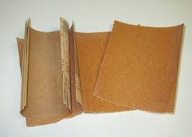  In the subsequent steps I will place my numbers on it, and the rest of the clock, but for now I can sand it a little using sand paper, and sand it enough so that when I swipe my finger, no splinters get caught, or when I swipe a piece of paper over the sides and edges of the clock no cracking noises will be heard. | 5 minutes
 | At the moment I have the ears of the animal and the face of it together. Now I will take pink fabric and cut it out in exact same shape of the two ears separately, however, of course they will be smaller (about 1cm cut from each side, in height and in width.) We have to be very careful to be accurate while cutting because it needs to look symmetric. Though while I will make sure that the pink fabric ears are the same shape as the actual ears. In order to cut the ears I will use strong scissors. I will be careful to cut neatly but later, if I need to, I can always trim the edges of the ears. | 5 minutes

Date | Numbered list of jobs and tools to use | Duration
Period 4 | 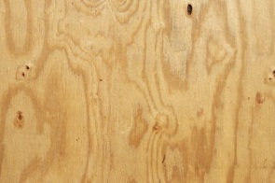  Today I will cut ply wood in the exact same shape of the balsa wood. For this I will need a hack saw, and ply wood, and of course you need a glue gun to glue it onto the balsa wood. Since it is a double period, I will have a lot of time. | 5 minutes
 | 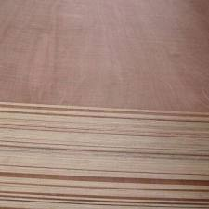  First I will take a piece of ply wood which is larger than 20cm by 20cm, and I will take a pencil as well as my balsa wood clock base. I will place the balsa wood clock base on top of the ply wood around the middle and outline it using the pencil. Next with a little bit of help from Mr. Thorburn, I will cut out the shape of the balsa wood clock base out onto the ply wood. | 20 minutes
 | 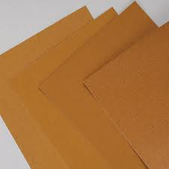  After that I will sand the ply wood clock base using sand paper. | 5 minutes
 | In the next 20 minutes of the first period I will update my process journal and follow the description that I gave previously. I will be checking the sub sheets and the other pages that Mr. Thorburn provided for us. | 20 minutes

Date | Numbered list of jobs and tools to use | Duration
Period 5 | Today I will be working on the mirror part of my clock. For this I will need a piece of a mirror at least as large as my clock which I can get from the school or buy somewhere. I will also need a glue gun and a few full glue sticks just in case, and in the beginning of the class I will make sure to plug the glue gun in so that it is warm for when I need it. I will also need my ply wood base clock which is colored in blue, a ruler, and a pencil. | 5 minutes
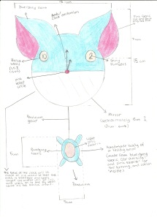
First I will take my ply wood clock base and I will find in the exact center of it. In order to do this, I will measure how long and wide the clock is using a ruler. According to my final design, the center will probably be 7.5cm from the side and 7.5cm from the bottom. Then I will draw a horizontal and a vertical line which runs through the center point, The mirror will go in the bottom part of the clock just on the horizontal line. The mirror will go on the place which is white in the picture.
 | 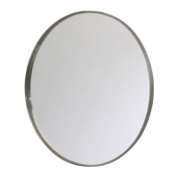  Next I will take the mirror and a black marker. But before I do anything with the mirror, I will take a pencil and a paper, draw a horizontal line, put the paper on the clock and outline the bottom of the clock and trace it. | 5 minutes
 | Next I will take that paper and cut it out accurately. I will be using scissors, and I will make sure that it is extremely accurate because it is not easy to cut mirror if you make a cutting mistake. | 5 minutes
 | Then I will place the paper on the mirror, and hold it down with my finger. I will keep holding it down until I am done tracing, so that I do not make any tracing mistakes. Next, I will take the marker, and outline the paper onto the mirror. | 5 minutes
 | Next, with the help of Mr. Thorburn, using a hacksaw, I will cut it out. I will make sure to do it accurately. | 5 minutes
 | After that, I will take the mirror that I cut out, and take the glue gun that is probably going to be warm by now, and put a lot of glue on the back side of the mirror. Before it dries I will quickly put it on the correct spot on the clock. | 5 minutes

Date | Numbered list of jobs and tools to use | Duration
Period 6 | In the second period of the double, I need to paint my clock which looks like the head of an animal. I will be painting it bluish grayish if I can find a paint color like that, if not, I will be painting it in light blue. For this I need to collect my materials, starting with my ply wood clock, the paint, a paintbrush, and something to paint on. | 5 minutes
 | Now I will start painting my clock, after dipping my paint brush in water than paint, and I will make sure it is very neat and the lines which the brush drew are not very visible. | 20 minutes
 | I will let it dry which will take a while, so in the mean time I will continue writing my process journal. I can also put away the materials that I do not need. | 35 minutes

Date | Numbered list of jobs and tools to use | Duration
Period 7 | At this moment I have the head of the clock (attached to the ears) and two pieces of pink fabric which are almost exact replicates of the animal’s ears but smaller. The thing that I need to do now is collect all my materials before I continue making my clock. The materials that I will need today is a glue gun, a craft knife, balsa wood, white foam board, ply wood, file and hack saw. If I need more things along I can always close it. Before I start anything plug the glue gun in so that it warms and I do not lose anytime. | 5 minutes
 | 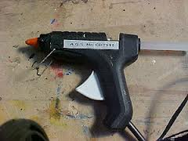  At this moment I will need to stick the pink fabric ears on to the ears of the clock. However, I might need to wait another 5 minutes so that the gun warms for it work correctly and stick. So during that time I will start making the eyes. For this I will need my balsa wood. I will be using a strip of balsa wood at least 8 centimeters by 5 centimeters so that I can cut out to even circles using a craft knife measuring 3 cm in diameter. I can use a compass to draw this in order to be accurate. Before I cut though, I will make sure to draw. I need a ruler in order to measure it so that it is very accurate. | 10 minutes
 | Since if I cut out the two circles but don’t have enough time to stick them onto the clock, they might get lost until our next class, I will not cut them out this period, so I have abundant time to stick them on and continue making the clock. Right now, I will just take the two pink fabrics, and see which one goes on the left ear (which is one is tilted to the left a little) and which one goes on the right ear (the one titled slightly to the right.) Though before I start cutting them I will make sure that the edges of the fabric are smooth and not spikey. I will trim around the fabric using a scissor. | 5 minutes
 | Next I will take the left inner ear and stick it on the left ear on the face. I will make sure that the left part of the inner pink ear will touch the left part of the actual ear so that it gives it a 3D effect. I will however, also make sure that the top of the inner ear does not touch the top of the actual ear because that would mean that it doesn’t fit perfectly. Like a puzzle piece I will stick the inner ear where it fits perfectly. | 10 minutes
 | I will repeat the same step with the right ear however this time I will stick it to the right side of the actually wooden ear. I will try to make the left ear and the right ear look symmetric and even. | 10 minutes
 | For the next ten minutes I will make sure that the ears look great. So that there is no fabrics sticking out from the side making it look uneven I will trim around the ear and cut out any left-over fabric pieces on both ears. I will make sure that I do not touch the fabric which is in the right place. | 10 minutes

Date | Numbered list of jobs and tools to use | Duration
Period 8 | It is the beginning of the class, and I will be making the eyes. We have them drawn out and for now I can just take that balsa wood which I have it drawn out on and take a craft knife. Collect of the materials which I will need including my clock, perhaps my pendulum, a file, sanding paper, hack saw, craft knife, balsa wood, and ply wood, as well as a glue gun. | 5 minutes
 | 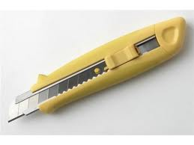  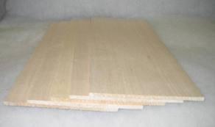  I can now take the craft knife, slide it open and make sure that without cutting myself, evenly cut out the first circle. While cutting around the circle, turn my hand around as well so that it is easier to cut the circle shape. Balsa wood is soft and easy to cut, so it shouldn’t be too big of a problem. Make sure that I cut very slowly so that I do not make a mistake. If I do make a mistake then take a ruler and pencil and a new piece of balsa wood, if I do not have more space on the one I have, and measure a three centimeter line horizontally and vertically touching each other half way, and draw a circle around it using a compass open up to three centimeters. | 10 minutes
 | If I cut it out correctly, I will have one circle cut out and before I cut out the next one, just sand this one so that I can easily stick it onto the clock when I am done. Take some of the sanding paper which I took at the beginning of the class and rub it all around the edges of the circle in order to make it smooth. I need to make sure that when I scrape the sides of the circle against a table, no splinters or no pieces of tiny wood should come out. | 5 minutes
 | Next I will repeat step one with the next circle, and then step 2. | 15 minutes
 | Next I have the two circles and I can stick them on the clock. This shouldn’t take long but I need to be very careful. Before I stick anything on the clock, plan out where the numbers will be. Make sure that they have at least 5cm in space between each of them. In addition to that, I will make sure that each number is at least 3 centimeters from the side of the circle. The size or shape that i draw the numbers in doesn’t matter as long as i do not press very hard so that I can  erase later. | 5 minutes
 | Now I can take the one of the two circles I have and stick the number 2 on it from my numbers on a paper which I received at the beginning of the unit. I will be very careful about aligning the numbers so that they are about .5 cm from each side of the circle so that it is almost completely in the middle. | 5 minutes
 | Next I will repeat the last step with the last circle but instead of sticking a 2 I will stick the number eleven on it in the exactly same way as the last circle. | 5 minutes
 | Next I will repeat the previous step on the ply wood. Next I will take on of the balsa wood circles with the number 2 or 10 stuck onto it and place it on the 2 on the ply wood. I will take a pencil and draw around it. Then I will repeat that step with the number 10 on the ply wood. | 5 minutes
 | Next I will put the two balsa wood circles somewhere safe, and using a hack saw cut out the two circles that I drew on the clock. Using sand paper I will sand the inner parts of the empty bit on the ply wood until there are no splinters. | 10 minutes
 | Next I will take the circle with the 2 on it and I will stick it exactly on the 2 on my clock. This will be the right eye of my animal. Therefore, before I stick it I will look at the clock and see if it makes sense that the right eye goes there if the whole clock is the actual face of the animal. Next I will take the glue gun which should be warm by now and stick it exactly where I planned to stick it. I will make sure that I stick it evenly and make sure that it really sticks. After I stick it in the place that I want, I will not touch it so that it does not move around and be ruined. | 5 minutes
 | I will repeat the last two step with the next circle that has an 11 on it. However, I will stick it on the 11 in the clock. If I don’t have enough time, I can come back at break time and/or lunch time. | 10 minutes

Date | Numbered list of jobs and tools to use | Duration
Period 9 | Today I will stick the ply wood onto the balsa wood together using a glue gun. I will need the ply wood, the balsa wood and a glue gun which I will plug in before I begin anything. | 5 minutes
 | I will take the balsa wood base and put the ply wood on top of the balsa wood and make sure that it fits just right. Next I will lift the ply wood a little and take the glue gun and put an abundant amount of it on the top of the balsa wood. I will press down the play wood and move it so that it fits just right and I will keep pressing with my hand for about 1 minute, until I am sure that the two wood pieces are completely stable and stuck together. | 5 minutes
 | For the rest of the period, I will update my process journal. | 40 minutes

Date | Numbered list of jobs and tools to use | Duration
Period 10 | Today I have the face and ears of the clock and the eyes made, and I still need to make the nose and the thing that will go on the pendulum. In order to begin this process and finish it in a timely manner, first I need to collect all of my materials which would be pink velvet fabric, scissors, compass, ruler, pencil, marker, balsa wood, ply wood, and craft knife. | 5 minutes
 | First I can start making the nose. For this I will need to open up the compass to 1 cm and draw a small circle about 1cm in diameter. I will make sure that the velvet is stabilized so that does not move while I am drawing it. | 5 minutes
 | 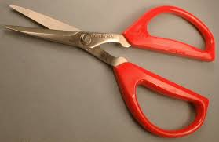  Next I can cut out the nose using scissors. I will make sure to cut it out very careful across the lines that I drew. When I cut it out, I will make sure I trim it a little without making it smaller so that the sides are smooth. I will put the circle somewhere where it will not get lost and somewhere where it will not fly away. | 5 minutes.
 | 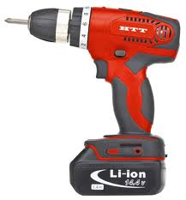  Next go to the Power Drill and take my clock. Right in the middle 15cm from the left or right side and 15 cm from the top and bottom right in the middle. I can drill a whole. I will make sure I use a ruler to measure it so that it is accurate, and I will make sure I plug the Power Drill in and ask Mr. Thorburn how to use it. | 10 minutes
 | 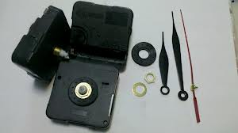  Next take the clock and the mechanism and with Mr. Thorburn’s help put the mechanism through the hole. | 5 minutes
 | Next take the velvet and take the glue gun which I plugged in at the beginning and which should be warm by now, and I will stick the pink velvet circle on the top of the mechanism. I will make sure that I apply just the right amount of glue, not too little so that it doesn’t stick or hold long enough, or not too much so that it overflows over the sides. I will try to keep my hands and fingers clean from the glue so that I do not transfer the glue to everywhere I touch including the tools and the clock. | 5 minutes
 | I will start my Process Journal and write for each of the days since the first day when I started. I will ma  ke sure to use a lot of details and check the document about the process journal. | 15 minutes

Date | Numbered list of jobs and tools to use | Duration
Period 11 | 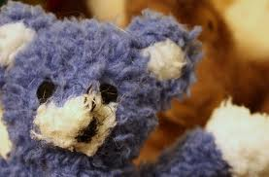  Today I need to make the toy that will go on the pendulum. In order to make this, I need a lot of grey, blue, and pink fabric, thread, sowing needle, cotton, and maybe even the remains of another little toy. If I can find a little toy that looks like what I want, the same colors, with no head, I can use it . | 5 minutes
 | 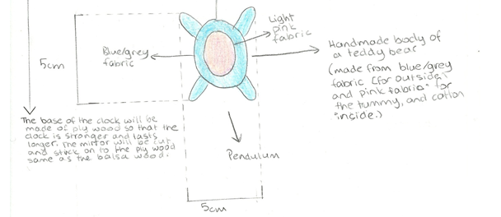  First I will take the bluish grayish fabric and cut out a bear without a head using scissors. Before I do that though I will take the measurements and draw it with a pencil. The body of the beat will be about 5cm in length and in width according to my design, excluding its hands and legs which is a change I want to make to the design. So first I will draw a shape like the one in the picture but without the hands and legs, so just the oval body, without the pink yet. Another change that I want to make is that I want the width, or the bottom line to be about 3cm long so that the bear does not look fat. | 5 minutes
 | Right now I have an oval which is 5cm in length and 3cm in width, and I need to draw another one which is exactly the same. Basically I will repeat the previous step on the same fabric but at least 5cm away in every direction from the other one. | 5 minutes
 | Next, using scissors, I will cut them out, and I will be very careful to be accurate. They should be exactly the same length because they will be sown together, and they should match. | 5 minutes
 | Now work on your process journal for the rest of the period. Make sure to make it detailed and interesting. Add pictures, and other forms of media into it, and make it descriptive. | 35 minutes

Date | Numbered list of jobs and tools to use | Duration
Period 12 | Now I need to continue making the body of the bear which will go on my pendulum. I have the oval part of the body, and today I need to sow them together, with cotton inside. For this, I will need white, grey, or black thread, a thin sowing needle, cotton, and the two ovals that I cut out. | 5 minutes
 | If it needs any trimming, I will trim the sides of the oval trying to maintain its size. Other than that, I will take the sowing needle and cut out a long piece of thread about 60cm in length. I will put it through the hole in the needle and tie a not so that it does not slip out. | 5 minutes
 | Next I can put the needle down in a safe place where it will not roll somewhere else, and where nothing will happen to the needle or the thread. I will start researching how to sow, on the internet, and if I have time at home, I will ask my grandmother to teach me. | 10 minutes
 | 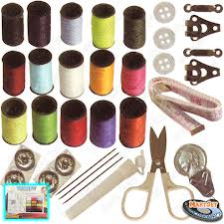  When I get the technique, I will take my two ovals and prepare the cotton for later. I will take the needle again and start sowing. While I am sowing, I will make sure that the ovals are on top of each other, they are touching each other everywhere, and that there is nothing sticking out. I will make sure that I do not sow the top, and that I leave place to add the cotton in. | 10 minutes
 | Next I will take the cotton and start filling it in the little pouch that I have. I will keep filling until it is completely full to the top and it is a little fat. | 5 minutes
 | Next I will sow the where I added the cotton to secure it. | 5 minutes
 | For the next 10 minutes I will update my process journal. | 10 minutes

Date | Numbered list of jobs and tools to use | Duration
Period 13 | Today I will put everything together. For this I will mainly need all of the parts of my clock and a glue gun which is warm and working and of course a clear work area. | 5 minutes
 | 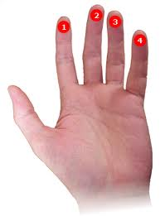  Now I will take the toy bear for the pendulum and stick it onto the large circle part using a glue gun. I will hold my finger on the bear and press it down on the pendulum for about a minute, until I am absolutely sure that it will not come off. | 5 minutes
 | Next I will take the pendulum, and with the help of Mr. Thorburn, I will place it in the correct place on the clock. | 5 minutes
 | Next I will check for any weak spots on the clock and if there are any, I will glue them stronger with the glue gun. | 5 minutes
 | After that, I will get as many batteries as the clock mechanism needs and I will place them in the correct area. | 5 minutes
 | Next I will take another set of batteries, however many are needed and place them in the pendulum if they are required to work it. | 5 minutes
 | After that I will check if my clock works. | 5 minutes
 | 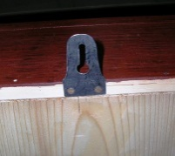  Lastly, I will cut out a piece of plastic in the form of a trapezoid and cut out a whole in the middle, large enough to stick a pin through. The trapezoid like piece of plastic will be long so that I have a flap at the bottom to stick to the clock. I will stick it using a glue gun. | 5 minutes

Date | Numbered list of jobs and tools to use | Duration
Period 14 | 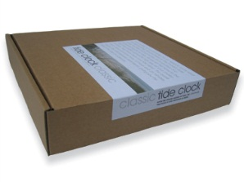  Today I will start making the box for my clock. I will need a large cardboard box, strong and large scissors, a craft knife, and a glue gun which I need to plug in before I begin doing anything. I will also need a paintbrush and paint in the colors white, black, blue, green, and red. | 5 minutes
 | I will get the large cardboard box and the pain brush and white paint, and as cleanly as possible, I will paint the box white all around. When I have one layer, I will wait for it to dry for about 5 minutes and paint another layer of white on top of it, so that it has a nice snow white color. | 15 minutes
 | Next I will take a pencil and write Dream Clock on it in a nice cursive bold font. I will make sure that it is very neat and aligned to the right side. It will cover about 1/3 of the box in length. | 5 minutes
 | Next I will take the black paint and paintbrush and write over the pencil in a much bolder but similar font. I will only write the Dream part in bold black and when I am done with that, I will dip the paintbrush in water and take the blue paint and I will paint over the Clock in a nice blue color. | 5 minutes
 | Then I will dip the paintbrush in water and take some red paint. In a more dramatic hand writing, something more italic but much smaller, about 50 point in computer writing. | 5 minutes
 | Next I will wait about 5 minutes for it to dry. | 5 minutes
 | After that I will update my process journal, and take some pictures, look at some web site templates to make my process journal on a web site since I will probably have a little more time. | 15 minutes

Date | Numbered list of jobs and tools to use | Duration
Period 15 | Today I will be working on my process journal, and I will finish it and polish it up, with pictures, videos, and other visuals. | 10 minutes
 | The rest of the period I will pick a template for my web site and start editing it to make it right. I want to make the web site design to have something to do with creating and designing, maybe art as well. I want the colors to be bright and shiny. I definitely do not want black, brown, or any other dark colors. The background can be white and there can be splatters of paint and everything. I will be using Wix to make my web site, and I want it to be a very interesting one, with sounds, videos, pictures, hyperlinks, and so on. Today I will be designing my process journal. | 30 minutes

Date | Numbered list of jobs and tools to use | Duration
Period 16 | Today I will copy and paste the information into my web site, and add the pictures and videos of the process, and edit the web site. I will try to make it interesting and eye-catching. It should be something that people want to look through. I will make sure that my information is neatly organized in chronological order of dates on different pages within the web site. | 40 minutes

Date | Numbered list of jobs and tools to use | Duration
Period 17 | Today I will go back to my clock and evaluate it against the specifications and record it in my process journal. This will take me a while because I want to make the evaluation very specific. | 40 minutes

Date | Numbered list of jobs and tools to use | Duration
Period 18 | After I have evaluated my clock against the specifications I will start my changes to my Create and changes to my plan. That is what I will be doing for the rest of the period. | 40 minutes

Date | Numbered list of jobs and tools to use | Duration
Period 19 | After I am completely done with the evaluation I will add that to my web site as part of my process journal, and I will interview my client again, with evidence, to see if this is what the client wanted the final design to look like, and fi they want any changes to be made. I will ask specific questions about what they like about it, what they think can improve, and why they thnk so, etc. I will be interviewing my client and seeing if they want anything different or if they like it. I will be going to the client’s home and checking if it matches, and I will be bringing all of the testing against specifications to life. | 40 minutes

Date | Numbered list of jobs and tools to use | Duration
Period 20 | I there are any changes that the client wants then I will make those, I will look over my site and publish it, and I will place my clock in the box and package it with tape like a real clock would be packaged. This period will not be extremely busy because I am basically done. | 40-50 minutes

Plan Evaluation:
Period 1: This period I will be drawing the final and detailed design, so I do not think that I will really have any problems. I think that it will be easy and it will only take some time. I have another period to do this, so I assume it will be okay.
Period 2: This period I am also working on my design. This is my final day to work on it, and I want to make it very detailed. But I do not believe that I will really have any problems. All I will be doing is drawing. I might need to make some changes to the create or the plan.
Period 3: This period I will start making my clock. I think it will be okay. In my opinion, it may be just a little difficult to do things as fast as the plan asks to, and make it very accurate and beautiful as well. I will not be using big tools today, just really a craft knife and everything which I already know how to use, however, I should still be very careful with using it correctly, and closing it when I am done.
Period 4: This period I will start using important materials and tools. I will be using ply wood which is hard to work with and hard to cut, and I will be using a hacksaw. I really need to ask Mr. Thorburn for his assistance in cutting the ply wood using that tool, because it might be the first time I am really doing it. Besides, there isn’t a lot of ply wood which we can use because everybody needs some, so I need to be very careful when cutting it to be accurate. In addition to that, I need to be very safe, because a hacksaw can be very dangerous.
Period 5: Today is the day that I am placing the mirror on my clock. This might be the most dangerous part of making my clock and the reason is that I am using dangerous tools including a hack saw, and I am using dangerous materials like glass and a mirror. Not only do I have to be extremely careful and attentive while using the hack saw, I also have to do the same when using the mirror, because it can break or just spew little pigments of glass if I do not handle it correctly. This is the first time that I am actually cutting glass, and a mirror, which is why I might be a little hard but other than that, I assume it will be very fun.
Period 6: Today I will be painting my clock. There is nothing to really worry about because all I am really doing is with a paint brush and with paint and of course with my clock, which might be one little thing that kind of scares me. If I make a mistake, it will be very hard to rewind it because I will be painting what I have of my clock, and if I paint the wrong place or it doesn’t look nice, I can’t really take the paint off easily. This is why I need to be extremely careful when using the paint and really plan out what it needs to look like.
Period 7: This period I will be making the pink fabric for the ears, and there is almost nothing to worry about, because I will only be using fabric which there will probably be a lot of an scissors which I really know how to use correctly and safely. In my opinion this period will be very interesting.
Period 8: Today I will be making the eyes, and there is almost nothing to worry about. This is because I will be using balsa wood and a craft knife. I need to be very careful while using the craft knife and I need to make sure that I close it when it I am done and handle it correctly so that I do not cut anyone. I need to make sure that I sand the balsa wood so that it doesn’t hurt anyone’s hand. In addition to that, I need.
Period 9: Today is the day that I stick the ply wood and the balsa wood together. I need to be very careful when using the glue gun for two things, the first one, not to burn anyone, and the second one not to glue the wrong place. This includes being neat with the glue and also putting it on the correct place on the clock, because it is really hard to scrape this glue off. In addition to that, once it is glued, it is pretty hard to take it apart.
Period 10: Today I will be making the nose which is no problem at all because I will have a lot of fabric so if I make a mistake in the cutting I can try again. In addition to that, I will not be using any extremely dangerous tools. I will just be using scissors, fabric and a compass. Though later, when I need to put in the mechanism which is the most important part of making the clock, it may be a little more difficult. This is because there is only one mechanism that is given to you and I have to drill a hole in the clock that I have. If I make a mistake in the drilling, it would ruin my clock, and if I make a kind of mistake with the mechanism, then I would ruin the mechanism. Either way, I have to be very careful to be accurate and delicate with the materials. I will be using a power drill which takes a little bit of experience to manufacture, which is why I will be asking for the assistance of Mr. Thorburn.
I need to be very careful when using that.
Period 11: Today is the day that I begin making the body of the bear on the pendulum. There will be almost no problem because all I will really be doing is drawing on fabric and cutting out, and of course measuring. I need to be very accurate when measuring and of course I need to use a ruler. I also need to be very accurate when cutting. Other than that, it will probably be pretty straight forward.
Period 12: Today I will be making the body of the bear. I will be using some dangerous materials including a sowing needle. I have to be extremely careful to use the needle correctly which is why I am going to research how to sow and ask my grandmother. In addition to that, this is basically the first time I have ever sowed something like this, so it might be a little bit tough in the beginning, but with some assistance it can happen.
Period 13: Today will be the day that I actually add the batteries to my clock. I need to make sure that they actually work, and that my clock works. I will also be making a hanger for my clock and I need to be careful when using the craft knife, to keep it closed when I am not using it, and to keep it in a safe place. In addition to that, I will also be gluing the body of the bear onto the pendulum today. I need to be very accurate when gluing it so that it is spread out evenly and lasts long. Other than that, I need to use the glue gun in a careful manner and keep it neat, and make sure that I have enough glue to keep the pendulum and the bear together for a very long time.
Period 14: Today is the day that I make the box of the clock which is extremely simple. All I need in a cardboard box in which my clock will fit into. Then on a piece of paper I will write Dream Clock, and stick it onto the box. There is nothing to really worry about and no dangerous tools used. It might only take a while to actually write it in a neat and symmetric font, with the correct look.
Period 15: Today I will be working on my process journal so there is basically nothing that will be so extremely difficult since I have worked with wix before.
Period 16: Today basically all I am doing is copying and pasting and making the web site look better which I know how to do. There is no safety guidelines and nothing that I need to pay close attention to since I have worked with Wix before.
Period 17: This period, I am basically evaluating my Create against the specifications. I will see if it is what I wanted and see if it fits my specifications. I will have real descriptive evaluations on whether it fits and how it can be changed so that it does fit.
Period 18: This period I will be evaluating the changes I made to the create and plan, all I can really do to make it better, is be accurate in my evaluations.
Period 19: This period I will be interviewing my client and seeing if they want anything different or if they like it. I will be going to the client’s home and checking if it matches, and I will be bringing all of the testing against specifications to life. There will probably be no problems with this.
Period 20: This period is the last period, and I will be adding the finishing touches to everything. I just need to be careful when handling the tools if I need any to improvise my design according to what the client said. I will try to be very careful when handling the clock and putting it in the box, and packaging it.

