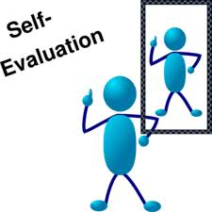
Evaluation
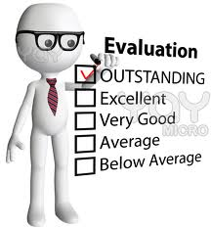
Made By: Rishabh Jain
Teacher: Mr. Thorburn
Class: 8S2
Word Count: 2615
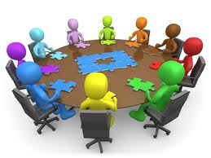

- Evaluation of the product

  - The housing system was manufactured so that setting up, transportation, building up if the shelter can take place in a matter of hours. Each shelter is self-satisfactory with all the equipment and technology kept in it, it is made with all the wiring and is fully furnished containing all the things a family needs to live. Transportation of these shelters is very easy as these shelters can be kept at a central location and will be flat packed as there are no curves, the shelter can be transported through planes, trains, cars, bus, trucks, etc. Once the shelters arrive, a team of 4 people can unload it, set one into position and set it up in less than two minutes without tools or machinery. The target cost of cost is $5000 so that it doesn’t costs much. Units can be combined together to form individual deployments that provide more living space for a family, or each unit can be used as an independent shelter for up to 4 adults. Configuration of the disaster shelters depends on the needs of the victims, number of people needing shelter and the amenities available at the rescue location. As these units referring to emergency shelters take up so little area they can be can be set up in a large area like a sports arena or convention center in case of larger calamity. Shelters would then, have their own climate control system, sanitation, a small kitchen, as well as areas for sleeping and living. Although the shelter is not aesthetically pleasing they are clearly many positive points to it like ease of transportation, modest price, adaptability to the conditions, and re-usability. These shelters can also hold one or two solar panels and can also handle one water catchment system through which the people living can use electricity in emergency and can get clean and safe drinking water through rain water depending on the acid content in the air of that region. Overall, this unit can provide and act as rehabilitation for victims hit by natural calamity.

- Product Testing
  - As now I have the 3d model ready, I am going to make a questionnaire for the model and give it to my client through which I will get additional information about my product and through the questionnaire I will get improvements about my model from my client.
  - Another way to test my product is by building a real life model and telling a family to live in there for one week, and after 1 week, through a questionnaire I will get all the information from them and analyze it to find improvements that could be made to my product.

- Reflection upon feedback from client

  - The client which is Red Cross is quite impressed and gave the feedback that these shelter/units are quite effective and efficient, and are low in cost. The idea of them being a shelter with complete furniture, infrastructure and wired for utilities is quite appreciated by them. The client also gave me very good feedback for the transportation of these units through trains, airplanes, ships etc. These shelters can be made up by 4 people at the site without any machinery and tools is a positive point as it is a source of instant relief from the victims. The client saw the model from the 2d to 3d and they appear to be the same and there are no changes. Yet, the client gave me some constructive feedback too like attaching a rain water collector or setting up a solar panel. They also said that making walls at 90 degrees and not slant would be better as there would be more space and it would be easier in manufacturing as it is easier to make walls at 90 degrees.

- Design Specification

  - Functions – The function of my model is to help saving people who are hit by natural calamity, and my product is a complete unit with infrastructure, interior furnishings, and wired for utilities which provides a person with all the things he/she needs to survive.
  - Materials – The material used for the shelter would be polycarbonate which is a plastic which is very light with stability, optical clarity, and heat resistance and very good as an electrical insulator. The plastic s also cheaper and reusable, so the material is beneficial.
  - Size – The size of the emergency shelters are appropriate for the survival of 4 people, and the dimensions are nearly of 2m by 2m by 2m. The size of the shelter is not so large so that more shelters can come in little area and more people can get a place to live.
  - Manufacturing Process – The shelter does not needs any use of machinery once reached at the spot of the disaster, it just needed to be fixed with the sides and a group of four people can make the shelter in less than 5 minutes. The shelter is a prototype and is largely made by hand.
  - Lifespan – As polycarbonate is tough and reusable, the shelter can be reused again and again at different times and once the use of the shelter is over and the target market does not needs it further, the polycarbonate can be send back and can be recycled and can be used to make some different thing. Also sending the material back can repay a small amount of investment made by the target market to buy the material.
  - Aesthetic Appearance – The model isn’t supposed to be aesthetically pleasing as it does not matter if it looks good or bad, it matters about the efficiency of the model and to what degree can it save people.
  - Cost – The shelter is made to cut down cost and as plastic is very cheap and the shelter will be made out of polycarbonate, the model doesn’t costs very much and it is quite cheap comparatively to other models. This emergency shelter is of $5000 which is not that much as compared to a person’s life.
  - Time – As the shelter is a prototype and it is largely made by hand, all the fitting are already provided and a team of four can make the model in less than 5 minutes, so these shelters cut down construction cost and can provide immediate relief shelter to the victims.

- Social Significance

  - Natural calamities can be of many different kinds, but the similarity in all, is their massive destruction in the area of their occurrence. The natural disasters are of many kinds, like drought and famine, flood, earthquake, hailstorm, cyclones.
  - In the wake of all these, in one sweep there is complete devastation and destruction, due to which normal life comes to a standstill. Loss of life and belongings of people get lost, blown away or swept away. The scene is one of awe, of some unknown power that appears to take revenge from the people of the area. One feels that, there will never again be life in the area, there will never again come up any construction in the area.
  - My emergency shelter creates hope in the hearts of people, that they can survive these disasters and start their life from a new point. My emergency shelters acts as a place for people to live temporarily when they can't live in their previous residence, similar to homeless shelters. Mine emergency shelters have a great social significance and can help people save life by providing them with a shelter which acts as a temporary place to live due to loss of home or personal belongings. My emergency shelters are very important and useful for victims and should be ready for deployment at places which are prone to natural disasters.

- Improvements

  - Attaching a rain water collector or solar panel. Attaching a rain water collector would enable the people living inside the shelter to drink pure water depending of the acid content in the air of that region. Putting a solar panel would enable people get light during night and can also be used for heating purposes.
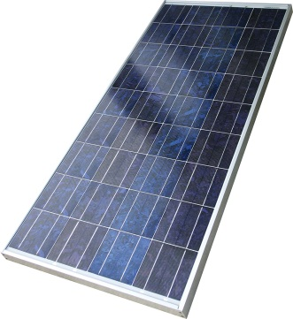
  - Making the walls at 90 degrees instead of slant walls would make more volume inside the shelter and people would have more space to breathe. Also bed can be attached to the walls and there would still be a lot of area left. Making slanting walls takes more effort from the manufacturing view as making the walls at 90 degrees. So by making the walls at 90 degrees it would be easier for the manufacturing companies.
  - There were some tiny improvements I could have made to my model, like there were some points where we could see glue coming out which made the shelter look shabby, so if I had put glue on the correct place evenly that could not have happened.
  - If I put a solar panel or rain water catchment system to show that the shelter could provide these facilities, the shelter would be more advanced and would seem to be with the available technology.

- Investigation

  - The investigation stage went quite good although the grade received was not satisfactory. I should have expanded on my specifications and my potential problems to be solved. Also in Design Brief I should have written about the real life model rather than the miniature model we will create. Same for specifications, I could have also improved more on my specifications as I had mention many broader specifications instead of small ones like to specify the number of doors, or windows and things like that. If I had done a better job in specifications, I could have done better in create phase by having more linage of my model to my specifications. Through this I learned and now have an idea of how to achieve a level six. Overall I thought that I did a pretty well job of investigating and answering the potential problems. It was a fun experience and came to know about the tools, and gained an experience about the things about building models and I researched about it. Through the investigation phase I learned a lot of things like visualizing 2d to 3d shapes, learning the uses of different tools, and knowing how to make design briefs and specifications for future. Investigation was very fun but at the same time confusing too, I didn’t know the expectation level of the work, but with the help of Mr. Thorburn I finished the investigation stage getting a satisfactory grade.

- Design

  - The design phase was good and the most creative part throughout the design cycle. Making designs through hand was a bit tough as visualizing 3d models and making a sketch which resembles 3d design is a bit hard and need artistic skills in it. The design phase was quite interesting as we got to show are creativity and we had to think about designs and then make them with the appropriate measurements. Thinking about designs matching my design specifications needed a bit thought and next time I would try to make some more unique models. Making three models was quite interesting but challenging as thinking about three different designs, but design stage was quite relaxing as we finally got our computer off and took paper and pencil which I am more used to, so the design phase was the easiest and the most challenging out of all of them. I could have made some improvements like adding more designs and making 2-3 pictures of each of my design from different angles would have helped me to have evaluated them more and maybe drawing a bit more designs would enable me to choose from a range of designs.

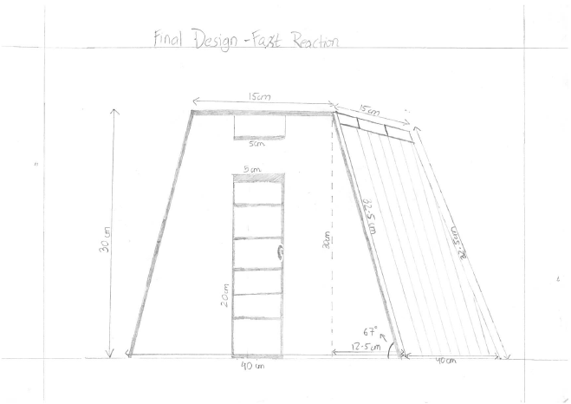

- Plan

  - The plan was an overall important part of my design cycle and was fun but time consuming as thinking about the steps and then writing them took a long time and then to write and think about all the safety precautions was a time consuming job. Also planning is the stage which I dislike because during the create phase anything may hit you in your face and then keeping up and following the plan gets difficult as the whole time schedule gets changed. Also following the plan seems like a burden as there is set goals and if you don’t do fulfill them then there is a guilty feeling within so it’s not in my preference. My performance in the plan stage was quite good and I got 6 so that mean’s I performed well and I was also able to follow my plan throughout the create stage. The plan helped me during the create stage as I knew if I finished the work stated for each day, I would complete my model before the deadline so the plan acted as a great guide. The planning stage was a bit frustrating as it made me think a lot about how to plan each action. We had to think about every step and many times we forget about what to do, we didn’t really know about the tools so we could have not written properly about using tools. Even though there were many obstacles, the planning stage was fun.

- Create

  - The create phase was the most crucial and one of the most important stage for a person designing. The create stage is the one in which the physical model was made and all the effort put into the investigate, plan, and design phase could be noticed in the final product made in the create phase. The create phase takes all the previous stages, mixes up all the information and makes a model resembling the design, through all the investigation by following logical steps laid out in the plan. The create stage I went through was very interesting, as in Design Technology, we get to use tools and materials and make a hand build model. I had firstly selected my material, plywood, then with the help of hand saw and Mr. Thorburn I cut all the pieces, then I edited the plywood, then I glued them, and I put a red cross to symbolize Red Cross. I was very successful in my view and am proud of myself of being able to make a satisfactory model. Although of this happiness, there were many problems I faced to achieve this happiness, there were problems like selection of materials, questions about the applications of tools, there were some critical stage where I got stuck in grieve problems like for instance the point where the fourth side wasn’t fitting in the structure but in these parts Mr. Thorburn helped us and brought us back on track. There were also some moments where I got distracted and wasted a lot of time but Mr. Thorburn always supported me throughout the create stage. Although through this create phase I didn’t really get a chance of cutting things and experiencing a large variety of tools, hand saw wasn’t allowed, but I couldn’t get an experience of using other saws but I also liked the create stage a lot. At first, visualizing the 3D model was a bit hard but later as I started to make it, the vision got stronger and stronger and I could easily visualize 3D models. Through the create stage I learned lots and lots and lots, like visualizing 3D models, collaboratively working with peers, Overall I learned a lot and gained a completely new experience though the create stage.
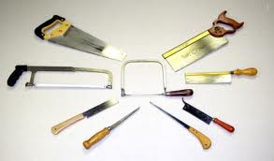

- Evaluate
  - Same answer from the 1st part of the Evaluation phase.

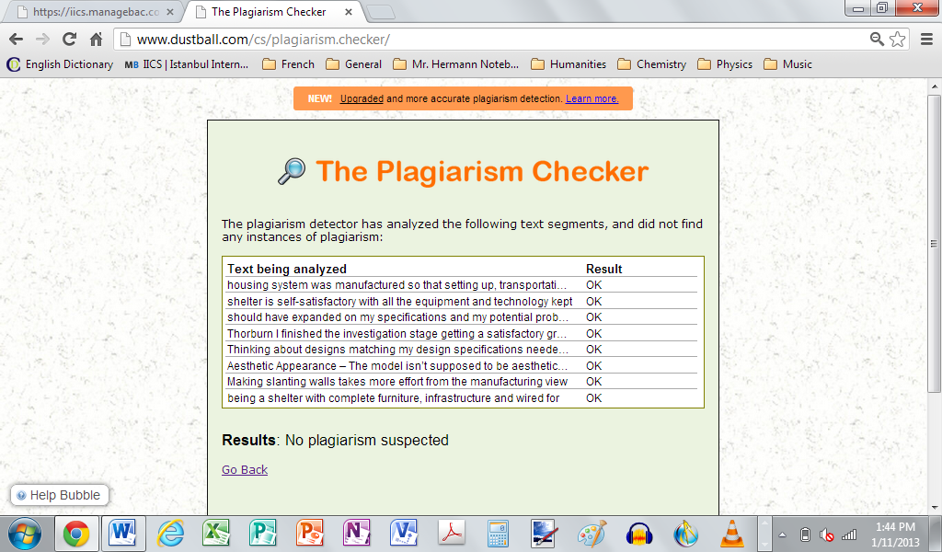
Reference

