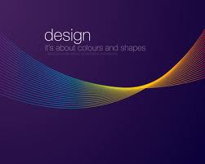
Design Stage – Clock Unit

Rishabh Jain
8S2
Mr. Brian Thorburn

Mood board
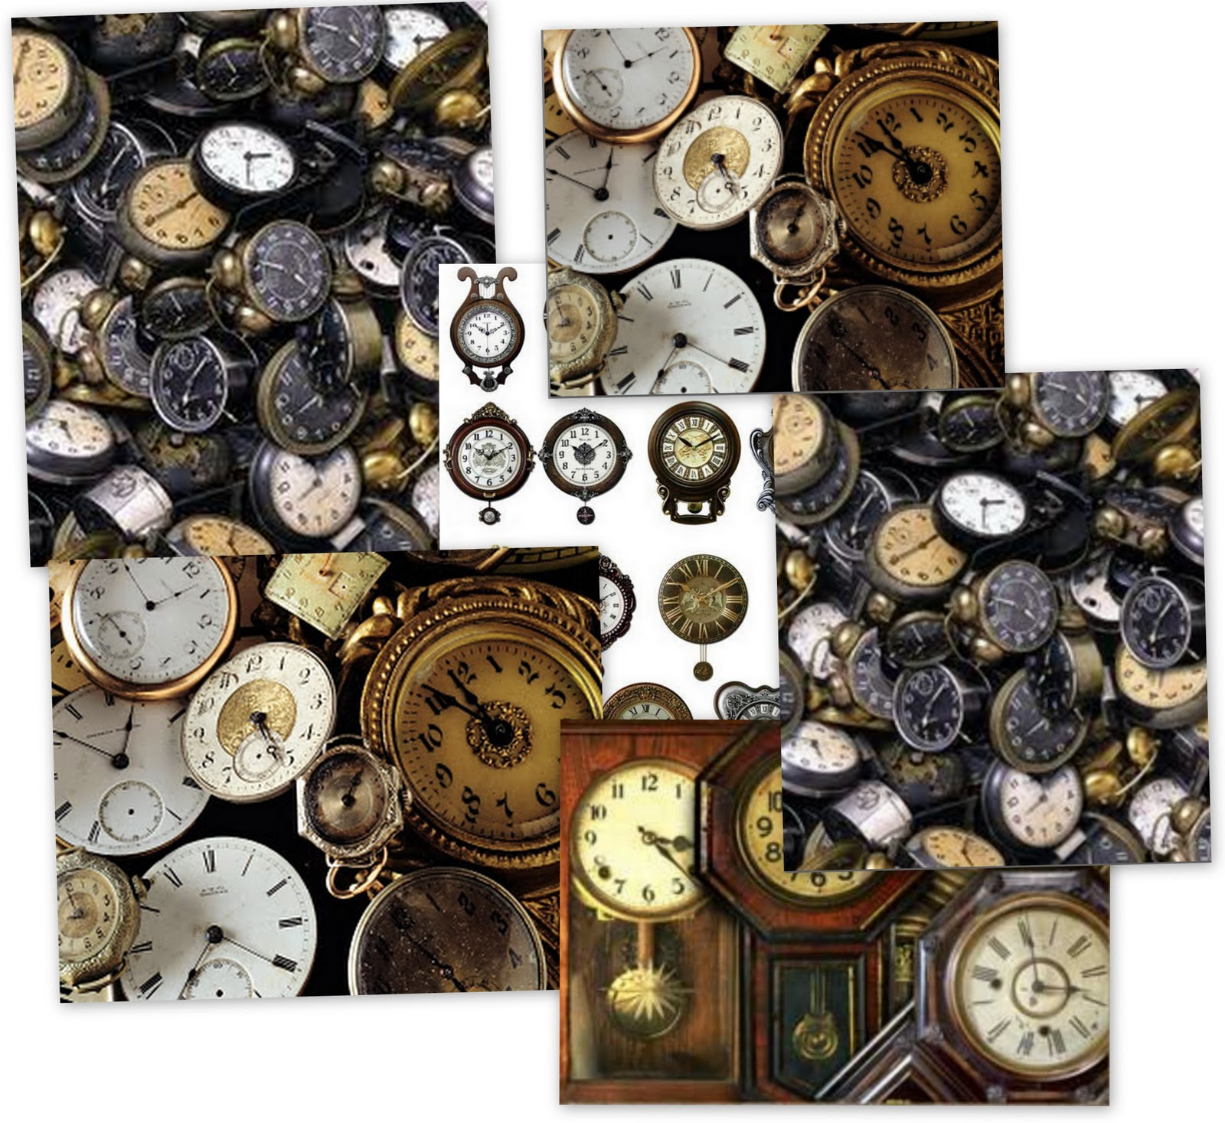
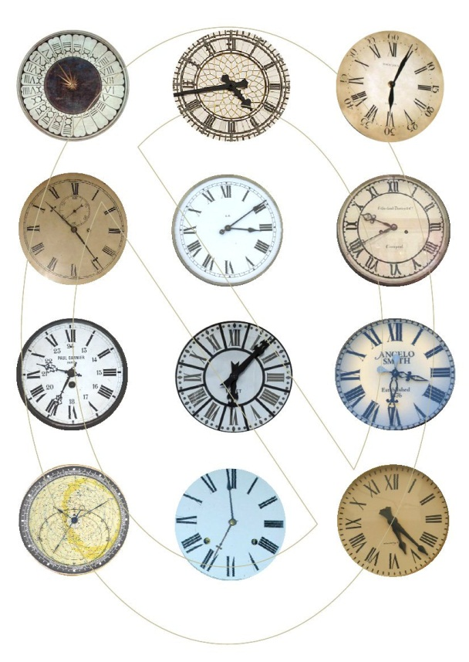
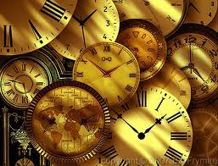

3 Initial Idea

Design Ideas
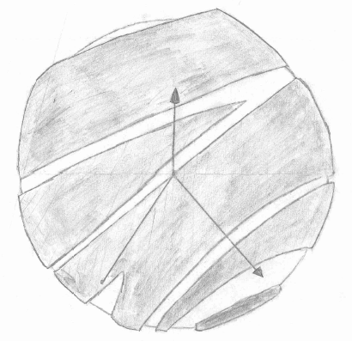
Idea Number 1:

Idea Number 2:
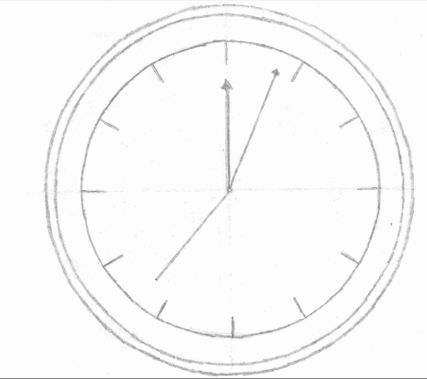

Idea Number3:
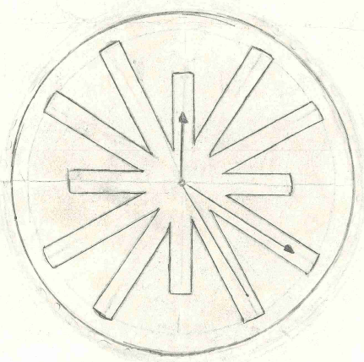

Design Idea 4:

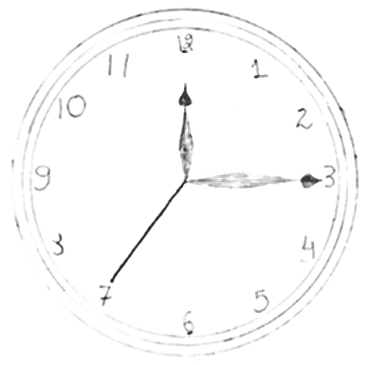

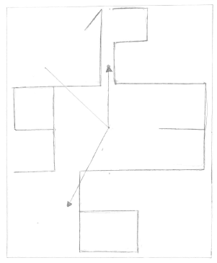
Design Idea 5:

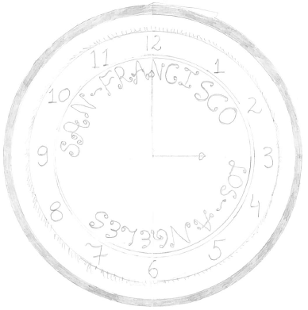
Design Idea 6:

Evaluation against Specifications
Design Specifications Weightings
- Target Market - My target market is my customer who wants a wall clock. (1)
- Functions - The function of the clock is to show time and help my customer to view time clearly while he is in his living room. (2)
- Materials - The materials needed to make the clock are mainly wood and paint. (2)
- Overall Size - the size is of 17.5cm in radius. (2)
- Equipment – Tools – Requirements – I need a variety of tools and saws to cut my project from inside and need some minor tools to give finishing to my model. (1)
- Manufacturing Process – Prototype, the product is made by hand and there is no use of machinery to mass produce and only simple tools are going to be used. (1)
- Maintenance Requirement – It needs to be cleaned as otherwise the product would look dull and needs changing of cells time to time. (1)
- Product life span and life cycle – The product is going to go on forever depending on the quality of wood but the life is equal to the life of the cell and a new cell would be required for the clock to work after the first one has finished. (1)
- Aesthetic Appearance – The product is round in shape, is on reddish blackish shade. (2)
- Quality Assurance – Quality assurance will be carried out to ensure that all systems and procedures are in place to ensure that a quality piece of clock is manufactured. The client will be constantly updated and consulted on all aspects of design and manufacture. (1)
- Quality control – The clock will be checked for quality and imperfection/damage at every stage of manufacture. Corrections/repairs will be made so that the chair is manufactured to the highest possible quality. A final quality check will take place before the clock is given to my client. (1)
- Cost - The clock will be a total of $20. The price includes materials only and does not include labor costs, tools, and equipment requirements. These are currently available in school. (2)
- Time Scale and Planning - 1-2 weeks (1)
- Health and Safety – Health and Safety regulation will be adhered to during the manufacturing process. When designing the clock will be rigorously tested for stability, accuracy and strength. Every effort will be made to ensure that the client or his customer cannot be misled when using this clock. (1)
The maximum points a clock can get is 19 points in total

Design Idea 1:
- Target Market - My target market is my customer who wants a wall clock.
  - The clock is a wall clock so it gets 1 point. It can also be used (through a stand) as a table clock.
- Functions - The function of the clock is to show time and help my customer to view time clearly while he is in his living room.
  - The function of the clock is too accurately see the time through it. It gets 2 points.
- Materials - The materials needed to make the clock are mainly wood and paint.
  - The clock is mainly made out of plywood and some other slabs of wood, and paint is needed so it gets 2 points.
- Overall Size - the size is of 17.5cm in radius.
  - The overall size of the clock is 20cm in radius, it gets 0 points.
- Equipment – Tools – Requirements – I need a variety of tools ad saws to cut my project from inside and need some minor tools to give finishing to my model.
  - The product is going to be made through saw and some minor tools for finishing so its gets 1 point.
- Manufacturing Process – Prototype, the product is made by hand and there is no use of machinery to mass produce and only simple tools are going to be used.
  - The product is a prototype as it is made completely through hand. So it gets 1 point.
- Maintenance Requirement – It needs to be cleaned as otherwise the product would look dull and needs changing of cells time to time.
  - The clock’s maintenance depends on the customer and would be sent perfectly neat and tidy to the customer. The clock gets 1 point.
- Product life span and life cycle – The product is going to go on forever depending on the quality of wood but the life is equal to the life of the cell and a new cell would be required for the clock to work after the first one has finished.
  - The clock would be made out of a good quality wood, and would go on forever if treated properly. So, it gets 1 point.
- Aesthetic Appearance – The product is round in shape, is on reddish blackish shade.
  - The clock has salsa red colored foam board and black plywood. So the clock gets 0 points.
- Quality Assurance – Quality assurance will be carried out to ensure that all systems and procedures are in place to ensure that a quality piece of clock is manufactured. The client will be constantly updated and consulted on all aspects of design and manufacture.
  - Quality would be assured and we would ensure the piece of clock manufactured. The clock gets 1 point.
- Quality control – The clock will be checked for quality and imperfection/damage at every stage of manufacture. Corrections/repairs will be made so that the chair is manufactured to the highest possible quality. A final quality check will take place before the clock is given to my client.
  - The clock would be checked at every step of the design cycle. The clock gets 1 point.
- Cost - The clock will be a total of $20. The price includes materials only and does not include labor costs, tools, and equipment requirements. These are currently available in school.
  - The clock costs $25 which is outside the limit so the clock gets 0 points.
- Time Scale and Planning - 1-2 weeks
  - The clock would take more than 2 weeks to be prepared. So it gets 0 points.
- Health and Safety – Health and Safety regulation will be adhered to during the manufacturing process. When designing the clock will be rigorously tested for stability, accuracy and strength. Every effort will be made to ensure that the client or his customer cannot be misled when using this clock.
  - The clock will be adhered to during the manufacturer process. So it gets 1 point.
The clock gets 12 points out of 19 points.

Design Idea 2:
- Target Market - My target market is my customer who wants a wall clock. (1)
  - The clock is a wall clock and is completely appropriate for my client. It gets 1 point.
- Functions - The function of the clock is to show time and help my customer to view time clearly while he is in his living room. (2)
  - The function of the clock is to show time accurately, so it gets 2 point.
- Materials - The materials needed to make the clock are mainly wood and paint. (2)
  - The materials needed to make the clock are plastic, high density foam board and paint. It gets 0 points.
- Overall Size - the size is of 17.5cm in radius. (2)
  - The size of the clock is 19.5cm in radius. It gets 0 points.
- Equipment – Tools – Requirements – I need a variety of tools ad saws to cut my project from inside and need some minor tools to give finishing to my model. (1)
  - The product is going to be made through saw and some minor tools for finishing so its gets 1 point
- Manufacturing Process – Prototype, the product is made by hand and there is no use of machinery to mass produce and only simple tools are going to be used. (1)
  - The product is a prototype as it is made completely through hand. So it gets 1 point.
- Maintenance Requirement – It needs to be cleaned as otherwise the product would look dull and needs changing of cells time to time. (1)
  - The clock’s maintenance depends on the customer and would be sent perfectly neat and tidy to the customer. The clock gets 1 point.
- Product life span and life cycle – The product is going to go on forever depending on the quality of wood but the life is equal to the life of the cell and a new cell would be required for the clock to work after the first one has finished. (1)
  - The clock would be made out of a good quality wood, and would go on forever if treated properly. So, it gets 1 point.
- Aesthetic Appearance – The product is round in shape, is on reddish blackish shade. (2)
  - The clock has a red interior and has a green exterior so it does not match the color scheme provided. It gets 0 points.
- Quality Assurance – Quality assurance will be carried out to ensure that all systems and procedures are in place to ensure that a quality piece of clock is manufactured. The client will be constantly updated and consulted on all aspects of design and manufacture. (1)
  - Quality will be assured and the clock will constantly be checked. So it gets 1 point.
- Quality control – The clock will be checked for quality and imperfection/damage at every stage of manufacture. Corrections/repairs will be made so that the chair is manufactured to the highest possible quality. A final quality check will take place before the clock is given to my client. (1)
  - The clock will be checked constantly for corrections. It gets 1 point.
- Cost - The clock will be a total of $20. The price includes materials only and does not include labor costs, tools, and equipment requirements. These are currently available in school. (2)
  - The clock is of $25. It is out of the budget, so it gets 0 points.
- Time Scale and Planning - 1-2 weeks (1)
  - The clock takes 3 weeks to be manufactured. It gets 0 points.
- Health and Safety – Health and Safety regulation will be adhered to during the manufacturing process. When designing the clock will be rigorously tested for stability, accuracy and strength. Every effort will be made to ensure that the client or his customer cannot be misled when using this clock. (1)
  - Health and safety will be adhered and the clock would be rigorously tested for stability, accuracy and strength. It gets 1 point.
The clock gets 9 points out of 19 points

Design Idea 3:
- Target Market - My target market is my customer who wants a wall clock. (1)
  - The clock is a wall clock and is completely appropriate to my client. It gets 1 point.
- Functions - The function of the clock is to show time and help my customer to view time clearly while he is in his living room. (2)
  - The clock will be used for watching time. It gets 2 points.
- Materials - The materials needed to make the clock are mainly wood and paint. (2)
  - The materials used are wood, paint and high density foam board. It gets 0 points.
- Overall Size - the size is of 17.5cm in radius. (2)
  - The size of the clock is 17.5 cm. It gets 2 points.
- Equipment – Tools – Requirements – I need a variety of tools ad saws to cut my project from inside and need some minor tools to give finishing to my model. (1)
  - The tools required are mainly saws and basic tools. It gets 1 point.
- Manufacturing Process – Prototype, the product is made by hand and there is no use of machinery to mass produce and only simple tools are going to be used. (1)
  - No machine will be used and it is a prototype. It gets 1 point.
- Maintenance Requirement – It needs to be cleaned as otherwise the product would look dull and needs changing of cells time to time. (1)
  - The clock needs to be kept cleaned and the battery is going to be needed to be changed. It gets 1 point.
- Product life span and life cycle – The product is going to go on forever depending on the quality of wood but the life is equal to the life of the cell and a new cell would be required for the clock to work after the first one has finished. (1)
  - The product will go on forever and would keep working if proper care would be given to the clock. It gets 1 point.
- Aesthetic Appearance – The product is round in shape, is on reddish blackish shade. (2)
  - The clock is of blackish-reddish color. It gets 2 points.
- Quality Assurance – Quality assurance will be carried out to ensure that all systems and procedures are in place to ensure that a quality piece of clock is manufactured. The client will be constantly updated and consulted on all aspects of design and manufacture. (1)
  - Quality will be assured so that a quality clock is made. It gets 1 point.
- Quality control – The clock will be checked for quality and imperfection/damage at every stage of manufacture. Corrections/repairs will be made so that the chair is manufactured to the highest possible quality. A final quality check will take place before the clock is given to my client. (1)
  - The clock will be checked at each stage of the create phase. It gets 1 point.
- Cost - The clock will be a total of $20. The price includes materials only and does not include labor costs, tools, and equipment requirements. These are currently available in school. (2)
  - The cost of the clock is $15. It is well inside the budget. It gets 2 points.
- Time Scale and Planning - 1-2 weeks (1)
  - It will take less than 2 weeks to make the clock. It gets 1 point.
- Health and Safety – Health and Safety regulation will be adhered to during the manufacturing process. When designing the clock will be rigorously tested for stability, accuracy and strength. Every effort will be made to ensure that the client or his customer cannot be misled when using this clock. (1)
  - The clock will be rigorously checked for stability, accuracy and strength. It gets 1 point.
The clock gets 17 points out of 19 points

Design Idea 4:
- Target Market - My target market is my customer who wants a wall clock. (1)
  - The clock is a wall clock so it fulfills the wish. It gets 1 point.
- Functions - The function of the clock is to show time and help my customer to view time clearly while he is in his living room. (2)
  - The function of the clock is to show time accurately. It gets 2 points.
- Materials - The materials needed to make the clock are mainly wood and paint. (2)
  - The materials used for the clock are high density foam board, plastic and paint. It gets 0 points.
- Overall Size - the size is of 17.5cm in radius. (2)
  - The size of the clock is 15cm in radius. It is too small. It gets 0 points.
- Equipment – Tools – Requirements – I need a variety of tools and saws to cut my project from inside and need some minor tools to give finishing to my model. (1)
  - The clock needs basic tools and equipment found in the lab to be built. It gets 1 point.
- Manufacturing Process – Prototype, the product is made by hand and there is no use of machinery to mass produce and only simple tools are going to be used. (1)
  - The clock is a prototype and would be made by hands with some tools. It gets 1 point.
- Maintenance Requirement – It needs to be cleaned as otherwise the product would look dull and needs changing of cells time to time. (1)
  - The clock would need some cleaning and changing batteries to be maintained. It gets 1 point.
- Product life span and life cycle – The product is going to go on forever depending on the quality of wood but the life is equal to the life of the cell and a new cell would be required for the clock to work after the first one has finished. (1)
  - The clock would go on forever if not disturbed, but new batteries are supposed to be put in so that the time would be accurate. It gets 1 point.
- Aesthetic Appearance – The product is round in shape, is on reddish blackish shade. (2)
  - The clock has a black interior with red numbers, and blue frame for outside with flowery pattern. It does not match the color scheme. It gets 2 points.
- Quality Assurance – Quality assurance will be carried out to ensure that all systems and procedures are in place to ensure that a quality piece of clock is manufactured. The client will be constantly updated and consulted on all aspects of design and manufacture. (1)
  - Quality assurance would be carried out to ensure that all systems and procedure are in place. It gets 1 point.
- Quality control – The clock will be checked for quality and imperfection/damage at every stage of manufacture. Corrections/repairs will be made so that the chair is manufactured to the highest possible quality. A final quality check will take place before the clock is given to my client. (1)
  - The clock will be checked for quality and imperfections, in order to reach the highest possible standard. It gets 1 point.
- Cost - The clock will be a total of $20. The price includes materials only and does not include labor costs, tools, and equipment requirements. These are currently available in school. (2)
  - The cost of the product is high as the clock costs $30 due to the plastic and the foam board and the reflective paint. It gets 0 point.
- Time Scale and Planning - 1-2 weeks (1)
  - It would take the clock 2 weeks to be build. It gets 1 point.
- Health and Safety – Health and Safety regulation will be adhered to during the manufacturing process. When designing the clock will be rigorously tested for stability, accuracy and strength. Every effort will be made to ensure that the client or his customer cannot be misled when using this clock. (1)
  - All health and safety regulations will be followed during the manufacturing of the clock. It has 1 point.
The clock gets 13 points out of 19 points.

Design Idea 5:
- Target Market - My target market is my customer who wants a wall clock. (1)
    - The clock is a wall clock and fulfills the wish of my client. It gets 1 point.
- Functions - The function of the clock is to show time and help my customer to view time clearly while he is in his living room. (2)
    - The clock is supposed to be used as a clock which shows time accurately. It gets 2 points.
- Materials - The materials needed to make the clock are mainly wood and paint. (2)
    - The materials needed to make the clock are poly-carbon, high density foam board, plywood and paint. It gets 0 points.
- Overall Size - the size is of 17.5cm in radius. (2)
    - The size of the clock is 40 by 40 cm which makes it a square shape. It gets 0 points.
- Equipment – Tools – Requirements – I need a variety of tools and saws to cut my project from inside and need some minor tools to give finishing to my model. (1)
    - The clock needs some very basic tools and saws to cut the wood. It needs basic tools. It gets 1 point.
- Manufacturing Process – Prototype, the product is made by hand and there is no use of machinery to mass produce and only simple tools are going to be used. (1)
    - The clock is a prototype and is made lonely by hand without the use of machinery. It gets 1 point.
- Maintenance Requirement – It needs to be cleaned as otherwise the product would look dull and needs changing of cells time to time. (1)
    - The clock needs cleaning up and changing batteries from time to time to keep the clock new looking and maintained. It gets 1 point.
- Product life span and life cycle – The product is going to go on forever depending on the quality of wood but the life is equal to the life of the cell and a new cell would be required for the clock to work after the first one has finished. (1)
    - The clock would go on forever and the batteries are needed to be changed over time. The clock gets 1 point.
- Aesthetic Appearance – The product is round in shape, is on reddish blackish shade. (2)
    - The clock is of wooden color with very thin strips of white color. It has red numbers and has white hands. It gets 0 points.
- Quality Assurance – Quality assurance will be carried out to ensure that all systems and procedures are in place to ensure that a quality piece of clock is manufactured. The client will be constantly updated and consulted on all aspects of design and manufacture. (1)
    - Assurance will be carried out to produce the highest piece of quality clock. It gets 1 point.
- Quality control – The clock will be checked for quality and imperfection/damage at every stage of manufacture. Corrections/repairs will be made so that the chair is manufactured to the highest possible quality. A final quality check will take place before the clock is given to my client. (1)
    - The clock would be again and again checked for imperfections and errors. It gets 1 point.
- Cost - The clock will be a total of $20. The price includes materials only and does not include labor costs, tools, and equipment requirements. These are currently available in school. (2)
    - The cost of the clock is $21. The clock is out of the range, it gets 0 points.
- Time Scale and Planning - 1-2 weeks (1)
    - It will take the clock 8 days to be prepared. It is under the time frame. It gets 1 point.
- Health and Safety – Health and Safety regulation will be adhered to during the manufacturing process. When designing the clock will be rigorously tested for stability, accuracy and strength. Every effort will be made to ensure that the client or his customer cannot be misled when using this clock. (1)
    - Health and Safety regulations would be carried out to prevent any accidents or injuries. The clock gets 1 point.
The clock gets 11 points out of 19 points.

Design Number 6:
- Target Market - My target market is my customer who wants a wall clock. (1)
  - The clock is perfectly appropriate for my client. It gets 1 point.
- Functions - The function of the clock is to show time and help my customer to view time clearly while he is in his living room. (2)
  - The function of the clock is to clearly show accurate time. It gets 2 point.
- Materials - The materials needed to make the clock are mainly wood and paint. (2)
  - The clock is made up of plastic, poly-carbon, and paint. It gets 0 points.
- Overall Size - the size is of 17.5cm in radius. (2)
  - The clock is huge with a size of 22cm in radius. It gets 0 points.
- Equipment – Tools – Requirements – I need a variety of tools and saws to cut my project from inside and need some minor tools to give finishing to my model. (1)
  - The clock needs basic equipment’s, fond in the lab to be built. It gets 1 point.
- Manufacturing Process – Prototype, the product is made by hand and there is no use of machinery to mass produce and only simple tools are going to be used. (1)
  - The clock is a prototype as no machinery is used to mass produce it. It gets 1 point.
- Maintenance Requirement – It needs to be cleaned as otherwise the product would look dull and needs changing of cells time to time. (1)
  - The clocks need to be cleaned and the batteries need to be changed time to time or the clock will not work. It gets 1 point.
- Product life span and life cycle – The product is going to go on forever depending on the quality of wood but the life is equal to the life of the cell and a new cell would be required for the clock to work after the first one has finished. (1)
  - The clock is made up of plastic which is a non-degradable object and takes a lot of time to degrade, so the clock will stay for a very long period of time. New batteries will be needed from time to time. It gets 1 point.
- Aesthetic Appearance – The product is round in shape, is on reddish blackish shade. (2)
  - The clock’s interior is of black color and the frame work is of yellow color with white color text and red color photographs. It does not match the color scheme. It gets 0 point.
- Quality Assurance – Quality assurance will be carried out to ensure that all systems and procedures are in place to ensure that a quality piece of clock is manufactured. The client will be constantly updated and consulted on all aspects of design and manufacture. (1)
  - Quality assurance will be carried out to ensure that all systems and procedures are in place. It gets 1 point.
- Quality control – The clock will be checked for quality and imperfection/damage at every stage of manufacture. Corrections/repairs will be made so that the chair is manufactured to the highest possible quality. A final quality check will take place before the clock is given to my client. (1)
  - The clock will be checked for errors and imperfections. The clock gets 1 point.
- Cost - The clock will be a total of $20. The price includes materials only and does not include labor costs, tools, and equipment requirements. These are currently available in school. (2)
  - The clock has plastic and poly-carbon which are a bit expensive and has many photographs and art sketches inside. It costs $26. It is over the budget, it gets 0 point.
- Time Scale and Planning - 1-2 weeks (1)
  - It will take 1-2 week to build the clock. It gets 1 point.
- Health and Safety – Health and Safety regulation will be adhered to during the manufacturing process. When designing the clock will be rigorously tested for stability, accuracy and strength. Every effort will be made to ensure that the client or his customer cannot be misled when using this clock. (1)
  - All the health and safety procedures will be followed so that no accidents or injuries occur. It gets 1 point.
The clock gets 11 points out of 19 points.
Client Feedback on Initial Design Ideas
- Initial Idea 1 :
The design is very well laid out and is quite impressive, it is a gem of a clock and looks wonderful. Although the clock is very impressive, it is too complicated of a clock with all the layers of cutouts, the color of the color of the clock matches in a way to my color schemes but does not matches perfectly. The color of the background, black, would look very shabby on my green colored wall and will take away the beauty of the clock. The clock is too complicated and I wanted a simple clock which has no numbers and have the most unique design. The clock does not have any numbers which I am happy about but it the layers take away the effect of the clock away. The clock is of 21cm in radius which is too big as 42cm in diameter would look bad on my wall as I wanted it to small due to the sitting arrangement which is close by to the clock. The clock is quite unique clock but does not match my requirements in the sense of size, color, and theme. This clock does not suits me due to its color and everything in my house is very simple and if there is suddenly a very complicated clock then the attention would directly go towards the clock and I want the clock to be simple and only used for time. The clock is very good but lacks the specifications which I need for my clock in my house. The clock costs $25, which is too much for a clock like this because the clock is not so attractive to me and I don’t like the clock, so $25 is too much for a clock which I don’t even like.

- Initial Idea 2:
The clock is not really what I wanted because the clock is a bit complex because it has a frame which I really hate and I don’t want a frame. The color scheme which I offered is completely different than the color scheme of the clock because the clock has a green interior and a black frame, so the interior would look like the same as my wall color so that would look horrible and also the black frame does not contrast with the color of the wall so the color of the clock would look very rubbish in my house. The clock is oversize as it is 20cm in radius which crosses the maximum limit of 17.5cm in radius, so the clock is oversize. The clock costs $30 which is too much for a clock such as this one; the cost is just too much in my opinion. The clock is also very complex and I wanted to have a simple clock, the interior of the clock is very common and I wanted it to be unique. The clock isn’t suitable for me as it is oversize, does not matches my color scheme, it is very common in interior and I want it to be unique, so the clock does not suits me.

- Initial Idea 3:
The clock is a gem of a clock and is perfectly suitable for my need. The clock is very simple and meets all my specification and is quite unique also as it has finger like projections coming out of the center and the hollow part can be backed up by the same color as the wall, and the color is reddish-blackish which is what I need. The size is perfect as it is of 17.5cm in radius and it is completely in size. It costs $15 which is completely in my budget. The clock is very light and it is perfect and would not break due to the light wood applied. I like the clock very much as it is perfect and contains and fulfills all my specifications and my needs in a clock. The clock is perfect and is completely appropriate and suitable for my use.

- Initial Idea 4:
This idea is completely inappropriate for my use and is completely different from what I need as the clock is oversize as it is of 20cm instead of 17.5cm, the clock has completely different colors and I wanted reddish-blackish while it has white and blue, it’s too complicated as I did not want a frame while it has a outer frame which makes it hazardous. It just reaches my budget so it is good from that aspect. The clock is not what I want because it has numbers which I don’t like and my main aim was to have a clock without numbers, but this clock has numbers, so this clock does not suits my requirements and I don’t like the clock so much and it is one of the most common clock in the world whereas I want a unique clock, so the clock is not appropriate for me.

- Initial Idea 5:
The clock is really good design wise and overall looks but does not matches the design which I need because mainly about the shape because the shape I wanted was a circle and what you are presenting me is a square shaped clock. Excluding the fact about the shape, it has humongous numbers on it which I hate and would not work for me. The color scheme does not match as the clock is of black color and white cutouts whereas I want a simple clock with reddish blacking color. The clock is of $25 which is too much for such a common clock which I can buy for $15, the cutouts are of poly carbon which does not change the appearance, the cutouts are of some nanometers in width which is of no use as even plastic would work instead of that and poly-carbon just increases the cost so it is of no use, overall the clock does not suits me and is of no use for me.

- Initial Idea 6:
The clock is not so good as it is one of the common looking clocks with a very simple background and is a bit complex due to the frame but I want a clock which is simple but should be unique whereas the clock is very common. The product quite matches my color schemes as it has black frame and red interior but it has numbers which I did not want, and from my point of view this clock does not has any uniqueness in it so I think $20 is too much for it.

Final Design Chosen:
The final design chosen by my client is the design number 3, which has finger like projections coming out from the center and is hollow from the middle. The clock matches all the specifications and all what the client wants. To begin with, the clock meets the aesthetic appearance of having reddish-blackish color, and then the clock has the exact same size as the client wants as the clock is of exactly 17.5cm in radius. Secondly, the clock is under the budget of the client as the clock is of $15 which is quite cheap as the clock is very beautiful and is very unique and it takes a lot of effort to make it and $15 is not a huge amount for it. The clock does not have numbers which makes it look very unique. The clock is very simple but unique, and follows the theme of simplicity.
The thing which makes the clock unique is the middle part of the clock which appears to be hollow and looks like there is nothing on it but actually the fact that it has a supporting sheet of foam-board makes it very unique, secondly the style of the finger like projections which act as numbers is very unique because it is not common. The clock is very light and is safe from damage as because it is made up of balsa wood and the foam-board, so the clock is very light and the foam-board acts as a protector of the clock so it is resistant to damages. The clock is not 3D and is not fluorescent as per the client. Basically the clock accepts each and every condition of the client. The main thing is that it fits all the conditions and is perfectly under the budget.

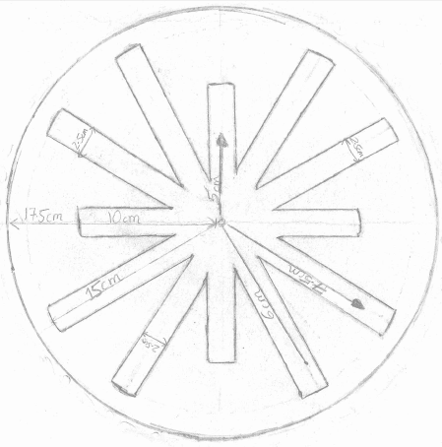
Detailed Design of the Clock

Evaluation of Final design Against Specification
- Target Market - My target market is my customer who wants a wall clock.
  - My target market is my father who wants a clock which is very unique but very simple at the same time.
- Functions - The function of the clock is to sow time and help my customer to view time clearly while he is in his living room.
  - The function of this clock is to show time as accurately and precisely as possible and to help the client to be aware of the time and to attend every meeting and important even on time.
- Materials - The materials needed to make the clock are mainly wood and paint.
  - The materials which are needed for the making of the clock is balsa wood, a very thin type of wood which can be cut out easily and can be painted easily, I am going to use this balsa wood as the face of the clock because I can paint it and cut it out easily, the other thing I am going to use is called High Density Foam-Board, which is a tough and rigid layer of foam-board. I am going to use the HDF to support the balsa wood and because the clock has nothing it between, I will put a white color foam board which will make it look like there is nothing at the back but there actually will be. The last thing I need is paint, I am going to use paint for painting the face of the clock, mainly red and black color. There will also use of plastic as the mechanism and the clock hands will be made up of plastic.
- Overall Size - the size is of 17.5cm in radius.
  - The size of the clock is 17.5cm because that is a standard size of a clock unless my client wants a huge one, and a size lessor greater than 17.5cm does not looks good. So, my clock has a size of 17.5cm.
- Equipment – Tools – Requirements – I need a variety of tools ad saws to cut my project from inside and need some minor tools to give finishing to my model.
  - There will not be the use of many tools, except some basic ones found in the lab. For cutting the balsa wood I need a craft knife and a file to smoothen it out. To cut the HDF, I need a hand saw as HDF is thick and hard. To stick both of them together, I need glue gun and an arrangement to hold the back mechanism and to put the clock hands. Mainly I need file, craft knife, and hand saw.
- Manufacturing Process – Prototype, the product is made by hand and there is no use of machinery to mass produce and only simple tools are going to be used.
  - The clock is a very easy piece to make, and it is being made for the first time so it is a prototype and I will make it by my hands with the help of Mr. Thorburn. As I am making it for the first time, there will be no use of special machinery or anything like that.
- Maintenance Requirement – It needs to be cleaned as otherwise the product would look dull and needs changing of cells time to time.
  - The clock is a very delicate piece of work and the color are very bright, so the clock needs to be cleaned with a wet clock so that it keeps shining and the color are bright and shiny. The clock’s body is good enough but the batteries needs to be constantly replaced by new ones because each battery has a specific duration of working period but if the battery is quite old, the clock may run slower or faster and it may mislead my client so the batteries need to be changed from time to time.
- Product life span and life cycle – The product is going to go on forever depending on the quality of wood but the life is equal to the life of the cell and a new cell would be required for the clock to work after the first one has finished.
  - The product (clock) will be made out of balsa wood which is a very good type of wood and will go on forever if the wood is not specifically destroyed. The HDF is a very tough and rigid material and cannot break or degrade quickly and is a very good material, so if the clock is maintained and not harmed, it will run for a very long period of time.
- Aesthetic Appearance – The product is round in shape, is on reddish blackish shade.
  - The clock appears to be of reddish blackish color as the face of the clock is painted with red and black color, the foam board is white so that it matches the wall color of my client and so it mixes up with the wall and the clock hands are going to be black and the second hand is going to be red.
- Quality Assurance – Quality assurance will be carried out to ensure that all systems and procedures are in place to ensure that a quality piece of clock is manufactured. The client will be constantly updated and consulted on all aspects of design and manufacture.
  - Quality assurance will take place and all the steps during the phase will be checked so that a very high piece of quality work is manufactured. The client will be again and again asked on the progress and will be shown the clock at every stage for customer satisfaction.
- Quality control – The clock will be checked for quality and imperfection/damage at every stage of manufacture. Corrections/repairs will be made so that the chair is manufactured to the highest possible quality. A final quality check will take place before the clock is given to my client.
  - The clock will be tested at every stage of the design phase for any errors or in-corrections, so that the clock is perfect when the client takes the clock. A final check will be given to the clock so that the highest possible quality of clock is given to my client.
- Cost - The clock will be a total of $20. The price includes materials only and does not include labor costs, tools, and equipment requirements. These are currently available in school.
  - The clock is made out of balsa wood which is very cheap and HDF which consists of 75% of the cost. Paint is not that costly. Summing up, the cost of the clock is $15 because it is a simple clock with simple materials in it.
- Time Scale and Planning - 1-2 weeks
  - The clock will be made in the time allotted in the create phase which is 1-2weeks as the clock has nothing except of cutting some parts and then pasting them. The most time is going to be taken for cutting the specific design on the clock face as making that with a pencil will take a lot of time as it has a very important play of angles in it.
- Health and Safety – Health and Safety regulation will be adhered to during the manufacturing process. When designing the clock will be rigorously tested for stability, accuracy and strength. Every effort will be made to ensure that the client or his customer cannot be misled when using this clock.
  - Health and Safety regulations will be carried out both in and outside the lab so that no accidents or injuries occur during the process of creation of the clock. The clock will be rigorously tested for stability and accuracy so that the clock may never mislead the client and never make him miss his meeting.

