Stage 2: Design MYP Design Cycle

By: Halim Kim
Class: 7S1 (Teacher: Mr. Thorburn)

Table of Contents
- The mood board …………………………………………………………page 2
- Design Ideas……………………………………………………………..page 3-5
- Evaluating against specification…………………………………………page 6-15
- Client Feedback …………………………………………………………….page 16-17
- Final design chosen and why………………………………………………page 18
- Final Design Ideal Develop……………………………………………….page 19
- Final Design……………………………………………………………….page 20
- Evaluate Final Idea against specification……………………………….page 21-22

1. Mood Board
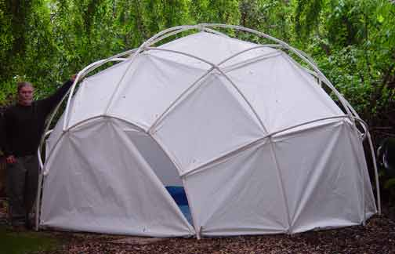
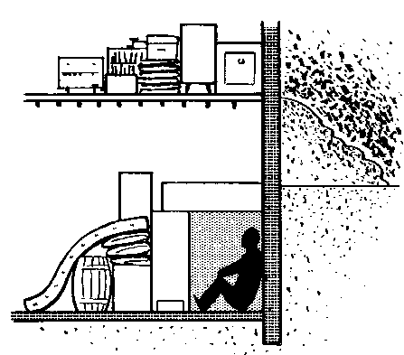
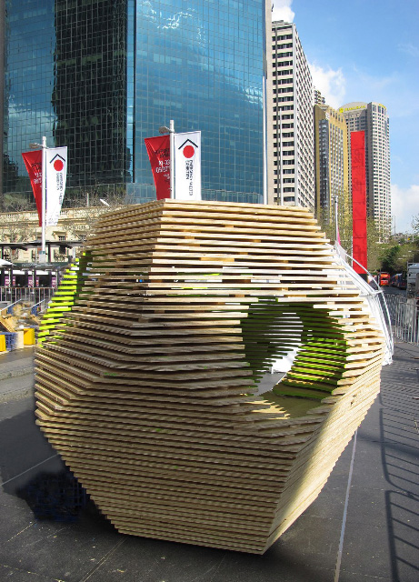
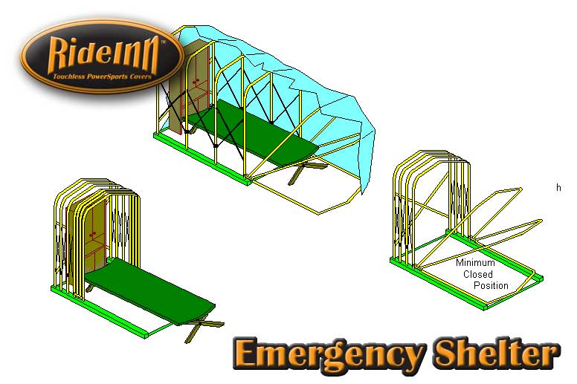
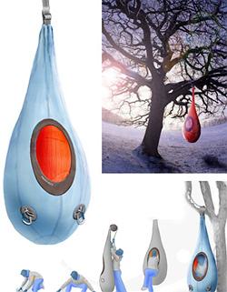
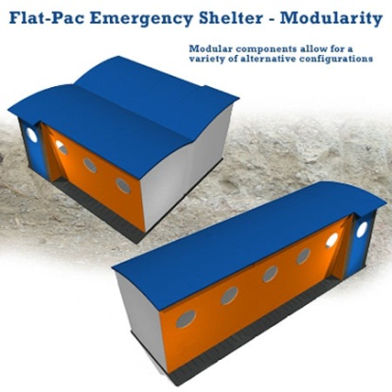
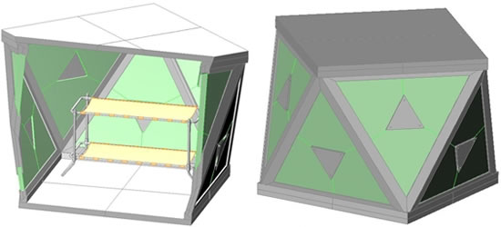
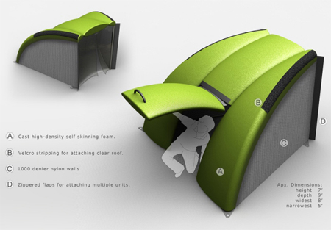
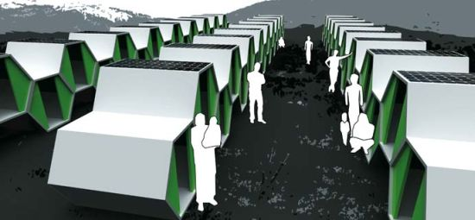
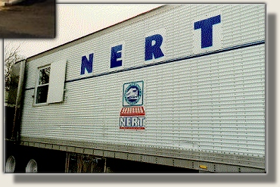

Mood Board

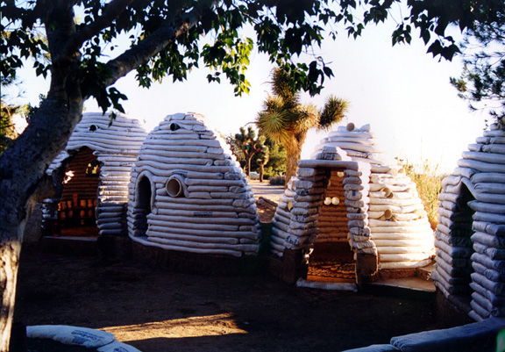
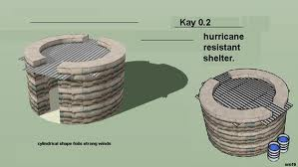
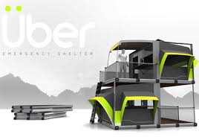

This shape has four emergency shelters in one. You could separate it if you want as well. The walls and floors are made out of wood.
- Design Ideas

- All roofs are metal
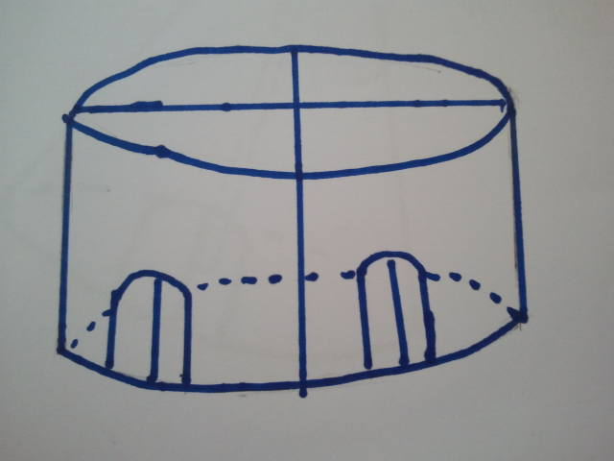

There are doors for each section and they are made out of cloth.

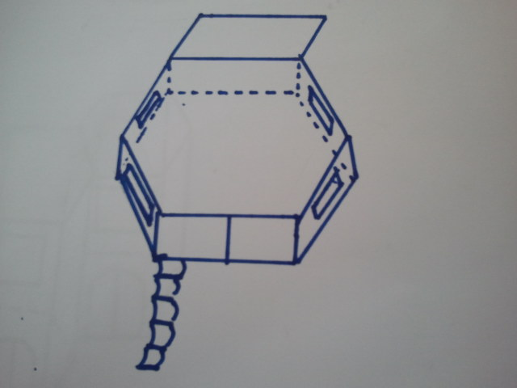
2)
Ceiling made out of metal. Floor made out wood bellow carpet. The walls are made out of wood.

Flap for the emergency shelter in a high place. Is made out of metal and is removable.
Windows made out of waterproof material.

Ladder for people to climb up and down when in high place. Is removable.

Cloth which would be used so that it would be easy for the people to go outside.

A metal pole that helps the emergency shelter to not break apart.

3)
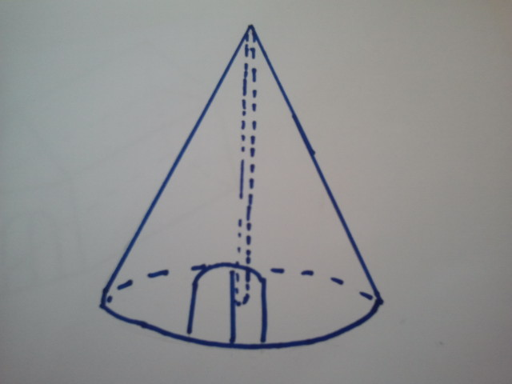

The walls are made out of wood and covered in cloth and some waterproof material so it doesn’t look bare. The shape of the emergency shelter is like a cone. It also represents a teepee.

Door is made out of cloth.

Floor is made out of metal.

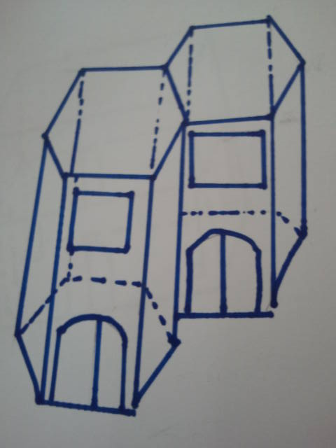

4)
Roof is made out of metal the walls of wood.

The windows are made from waterproof material the doors of cloth.

The inspiration of this emergency shelter is the Jusangjeoli in Korea which is a columnar jointing. These can be easily arranged so that they are right next to each other.

The Roof is made out of metal so it can block any leaking.

5)
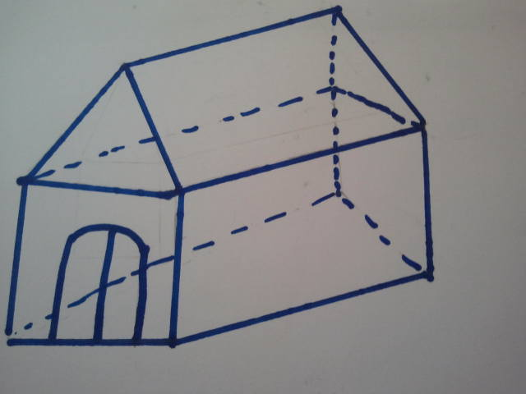

The walls are made out of wood. Because the shape is more like a house, it becomes a comfy pace. One side of the wall is made out of waterproof material.

The door is made out of cloth.

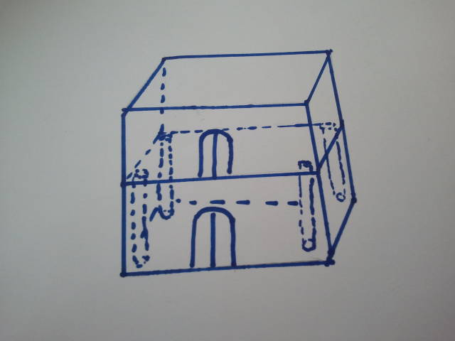
Doors are made out of cloth.
Ceiling made out of waterproof material. The walls out of wood..
6)

/metal poles that help two shelters stick together. The inspiration of this shelter is building blocks.

Floor is made out of metal.

- Evaluate against Specification

- 1st Model

Target Market (2): The target market for my emergency shelter is highly populated China. This emergency shelters has four rooms in one which makes it possible for a lot of people to live in one emergency shelter. (2 out of 2)
Functions (1): The function that the emergency shelter has to have was to give warmth and create shelter for the people. This emergency shelter creates warmth because a lot of people are going to be living in one emergency shelter which creates heat, and it also creates a home for the people who are living in the emergency shelter. (1 out of 1)
Materials (2): The materials that I want to use for my shelter are metal, wood, waterproof material, and cloth material. This shelter’s roof is made out of metal, the doors are made out of cloth, and the rest is made out of wood. However this model doesn’t have waterproof material. (0 out of 2)
Ergonomics/ overall sizes (2): The size that I wanted for my shelter was to be big enough to fit 5-10 people. This shelter creates room for about 5-10 people because it is especially made for large amounts of people. (2 out of 2)
Manufacturing processes and quantity (1): I stated that I wanted about 1,050 emergency shelters manufactured for the large amount of populations that would be effected by the flood. I think there has to be about 1,050 of this emergency shelter. (1 out of 1)
Equipment/ tools- requirements (1): The tools that I need are Hack Saw, Coping saw; Steal rule, Snips, File, Engineer square, Pliers, Scissors, Screw driver, Hammer, Tenon saw, and a Craft knife. I think I will need all of these tools because I will have to cut wood, metal and screw things in. (1 out of 1)
Maintenance Requirements (1): I stated that the emergency shelter shouldn’t be crowded because the emergency shelter could break. I think that because this shelter is supposed to be for large amounts of people there is a chance that it could be overcrowded and collapse. (1 out of 1)
Product life span and life cycle (1): I wanted my emergency shelter to be reusable and it is reusable because this shelter does not decay. (1 out of 1)

Aesthetic appearance (Shape, color, texture) (2): I wanted the shape to be a hexagonal- prism. I also wanted the color to be translucent so that the people could have some privacy but enough so that they can see what was going on outside. This shelter does not have any of these traits. (0 out of 2)
Quality Assurance (1): I said the Quality Assurance will be held. It will be held. (1 out of 1)
Quality Control (1): I said that the quality control will be held once a month. It will be held once a month. (1 out of 1)
Cost (2): I said that100TL would be enough. I think that it will be the amount that it would take for me to make my emergency shelter. (2 out of 2)
Time scale and planning (1): I said that it would take roughly 24 hours to make my emergency shelter. I think it would take about that time to make it. (1 out of 1)
Health and safety (1): I said that I would check the stability of my emergency shelter again and again and I will check the stability for the sake of the people who are going to use my shelter. (1 out of 1)
Overall score: 15 points

- 2nd Model

Target Market (2): I said that the target market is the people in China and China has a lot of people. This emergency shelter is especially made for the large population in China. (2 out of 2)

Functions (1): The function that the emergency shelter is supposed to do is give warmth and shelter to the people of China. This shelter has a carpet which gives warmth and it gives a shelter. (1 out of 1)
Materials (2): The material that I wanted my emergency shelter to be made out of was metal, wood, cloth, and waterproof material. The ceiling of my shelter is made out of metal, the window is made out of waterproof material, the door is made out of cloth and the rest is made out of wood. (2 out of 2)
Ergonomics/ overall sizes (2): I said that the house should be for 5-10 people and this emergency shelter is made for 5-10 people. (2 out 2)
Manufacturing processes and quantity (1): I was going to make 1,050 emergency shelters and I think that it would be enough. (1 out of 1)
Equipment/ tools- requirements (1): I stated a lot of tools to make my emergency shelter such as: the Hack Saw, Coping saw; Steal rule, Snips, File, Engineer square, Pliers, Scissors, Screw driver, Hammer, Tenon saw, and a Craft knife. I will need all of these tools because these are efficient in cutting wood and metal which I am going to use to make my emergency shelter with. (1 out of 1)
Maintenance Requirements (1): I stated that the emergency shelter shouldn’t be too crowded because it would cause the unique shape to burst. I think this shape is fit for the amount 5-10 people and will not burst. (1 out of 1)
Product life span and life cycle (1): I mentioned in my specification that the emergency shelter should be able to be used again and again and this emergency shelter will be able to be used again and again because it is not made to decay overtime. (1 out of 1)
Aesthetic appearance (Shape, color, texture) (2): I said that the shape should be a hexagonal- prism and that it should be translucent. This emergency shelter is in the shape of a hexagonal- prism but however it only has some amount of translucent material. (0 out of 2)
Quality Assurance (1): I said that quality assurance will be held and it will be held. (1 out of 1)
Quality Control (1): I said that the quality control will be held once a month and it will be held once a month. (1 out of 1)
Cost (2): I said that the cost should be about 100TL so people will buy my emergency shelter and I think that the materials used for model number 2 will cost about 100 TL. (2 out of 2)
Time scale and planning (1): I said that it would take about 24 hours to make my emergency shelter and I think that it will take about that amount of time to make. (1 out of 1)
Health and safety (1): I stated that I will check numerous times that this emergency shelter will be stable and I will check. (1 out of 1)
Overall score: 17 points

- 3rd Model

Target Market (2): The target market was the population of China who got affected by the flood. This emergency shelter is especially made for the people who got affected by the floods in China. (2 out of 2)

Functions (1): The function that I wanted the emergency shelter to do was give the person warmth and giving the person shelter. This emergency shelter does give any source of warmth though it does give shelter. (1 out of 1)

Materials (2): The materials that I wanted to use to make my emergency shelter were: Waterproof material, wood, metal, and cloth. To make this emergency shelter I will need all of these materials. ( 2 out of 2)

Ergonomics/ overall sizes (2): I mentioned in my specification that the overall size should be able to fit about 5-10 people. I think that this emergency shelter lacks space to fit 5-10 people. (0 out of 2)

Manufacturing processes and quantity (1): I said that about 1,050 emergency shelters should be the quantity but I think we need more than this because one emergency shelter does not fit a lot of people. (0 out of 1)

Equipment/ tools- requirements (1): The tools that I needed to make my shelter was Hack Saw, Coping saw; Steal rule, Snips, File, Engineer square, Pliers, Scissors, Screw driver, Hammer, Tenon saw, and a Craft knife. I will be using all of these tools since I will be using a variety of materials. (1 out of 1)

Maintenance Requirements (1): I said that the emergency shelter shouldn’t be too crowded or the unique shape will burst. I think even if it is not full of a lot of people, there is a chance that it would burst. (0 out of 1)

Product life span and life cycle (1): I said that the emergency shelter should be reusable and it is reusable. (1 out of 1)

Aesthetic appearance (Shape, color, texture) (2): I wanted the shape to be a hexagonal-prism and I wanted it to be translucent. The color is translucent but the shape is not a hexagonal-prism. (2 out of 2)

Quality Assurance (1): I said that the quality assurance will be held. It will be held. (1 out of 1)

Quality Control (1): I said that the quality control will be held once a month. It will be held once a month. (1 out of 1)

Cost (2): I said that the cost should be a bout 100TL so that people could afford to buy it. I think Model number 3 will be about 100TL or even less. (2 out of 2)

Time scale and planning (1): I said that that time scale and planning will take about 48 hours. I think it will take about 48 hours. (1 out of 1)

Health and safety (1): I said that after the product was made, the emergency shelter would be checked again and again to check if it is stable or not. (1 out of 1)

Overall Score: 15 points

- 4th Model

Target Market (2): The target market is the people of China and there is a large population in china. This emergency shelter is made for the people of china who are affected by the flood. (2 out of 2)

Functions (1): I said that the function should be giving people warmth and shelter. I think it wouldn’t give the people warmth but it would give them shelter. (1 out of 1)

Materials (2): I said the materials that should be included to make the emergency shelter were waterproof material, metal, wood, and cloth. The roof is made out of metal, the window is made out of waterproof material, the door is made up of cloth, and the rest is made out of wood. (2 out of 2)

Ergonomics/ overall sizes (2): I said that the overall size of the emergency shelter should be able to fit about 5-10 people due to the fact that China is highly populated. I think that this emergency shelter will be able to fit about 5-10 people. (2 out of 2)

Manufacturing processes and quantity (1): I said that about 1,050 will be enough and I think because this could house a lot of people, 1,050 of them will be alright. (1 out of 1)

Equipment/ tools- requirements (1): The tools that I need are: Hack Saw, Coping saw, Steal rule, Snips, File, Engineer square, Pliers, Scissors, Screw driver, Hammer, Tenon saw, and a Craft knife. Because I will need to cut a lot of materials, I think I will need all of these tools. (1 out of 1)

Maintenance Requirements (1): I said that the house shouldn’t be too crowded because the unique shape will burst open. I think that the shape is fit for the amount of people that I wanted it to house. (1 out of 1)

Product life span and life cycle (1): I said that I wanted the emergency shelter to be reusable and I made this shelter so that it was possible for the shelter to be reused. (1 out of 1)

Aesthetic appearance (Shape, color, texture) (2): I said that the shape needs to be a hexagonal prism and that it needs to be a translucent color. The shape is a hexagonal prism and there is some translucent material for the windows. (2 out of 2)

Quality Assurance (1): I said that the quality assurance will be held and it will be since the emergency shelters are very big and tall. (1 out of 1)

Quality Control (1): I said that there will be a quality control as well. There will be a quality control. (1 out of 1)

Cost (2): I said that the cost would have to be about 100TL. The size of this emergency shelter is big so I think the materials will cost a lot of money. (0 out of 2)

Time scale and planning (1): I said that the time that the emergency shelter will take to make is 48 hours. I think that this emergency shelter is very big and will take a lot of time to make it. (1 out of 1)

Health and safety (1): I wrote that the emergency shelter ill be checked numerous times so that the shelter will be sturdy. There will be a health and safety check. (1 out of 1)

Overall score: 17 points

- 5th Model

Target Market (2): The target market is the large population of China. I think that this emergency shelter will house a fair amount of people. (2 out of 2)

Functions (1): The functions that the emergency shelter is supposed to do are giving warmth and giving the people shelter. Because there is a window, the warmth wouldn’t be a problem at all and the emergency shelter provides shelter to the people of China. (1 out of 1)

Materials (2): The materials that I wanted to use for my shelter was Waterproof material, Wood, metal, and cloth materials. This model includes all of the materials that I stated in the specification. (2 out of 2)

Ergonomics/ overall sizes (2): I said that the overall sizes should be able to fit 5-10 people. This shelter is big enough for 5-10 people. (2 out of 2)

Manufacturing processes and quantity (1): I said that about 1,050 emergency shelters should be made for the quantity. But I think there needs to be more shelters for the population to fit. (1 out of 1)

Equipment/ tools- requirements (1): The tools that I wanted to use to make my emergency shelter was Hack Saw, Coping saw, Steal rule, Snips, File, Engineer square, Pliers, Scissors, Screw driver, Hammer, Tenon saw, and a Craft knife. I think I will need to use all of these materials because I will need to both wood and metal. (1 out of 1)

Maintenance Requirements (1): I said that the unique shape should not be crowded because it will break. Because the shape is like a normal house, I don’t think that the shape will be overcrowded with people. (1 out of 1)

Product life span and life cycle (1): I said that the emergency shelter should be reusable again and again in other emergency shelters. This shelter can be used again and again in other emergencies. (1 out of 1)

Aesthetic appearance (Shape, color, texture) (2): I said that the shelter should be a hexagonal- prism and that the color should be translucent. The shelter shape is not a hexagonal- prism and there is only a little bit of translucent material. (0 out of 2)

Quality Assurance (1): I said that there should be a quality assurance. There will be a quality assurance. (1 out of 1)

Quality Control (1): I stated in my specification that there will be a quality control. There will be quality controls. (1 out of 1)

Cost (2): I said that the cost should be about 100TL. I think because the size is very big like a normal house, I think that it would cost too much to build this emergency shelter. (0 out of 2)

Time scale and planning (1): I said that the time scale that it would take to make my emergency shelter was 48 hours. Because this emergency shelter is very big in size, I think it will take more time to make the emergency shelt.er. (1 out of 1)

Health and safety (1): I said that I will check if the emergency shelter again and again to check its stability. I will check. (1 out of 1)

Overall Score: 15 points

- 6th Model

Target Market (2): I said that the target market should be the large population of China. Because this emergency shelter could be stacked up like building blocks, we can fit a lot of people in one emergency shelter. (2 out of 2)
Functions (1): The functions that the shelter is supposed to have is giving the people warmth and giving the people shelter. This shelter does not give much warmth but it does give a shelter. (1 out of 1)

Materials (2): The materials that I want to use for my emergency shelter are metal, wood, cloth, and waterproof material. This shelter’s roof is made out of waterproof material, the door is made out of cloth material, the poles that help stick two shelters together and the floor is made out of metal, and the rest is made out of wood. (2 out of 2)

Ergonomics/ overall sizes (2): I noted in my specification that the overall size should house 5-10 people. The shelter is about the size of a boxcar and can house 5-10 people or more. (2 out of 2)

Manufacturing processes and quantity (1): I said that the quantity should be about 1,050 emergency shelters because there are a lot of people in China. I think we need more for the “box car” emergency shelter to create an environment for people to live in. (1 out of 1)

Equipment/ tools- requirements (1): The tools that I noted that I needed were tools that would cut both wood and metal. I think that because the materials are of a variety I will need all of these tools to build my emergency shelter. (1 out of 1)

Maintenance Requirements (1): I said that the requirements that the emergency shelter to have was that it should stay sturdy even though there are a lot of people in the emergency shelter, it wouldn’t be problem because the floor is metal and is very sturdy. (1 out of 1)

Product life span and life cycle (1): I said that the emergency shelter should be reusable in other emergency shelters but this shelter isn’t reusable because after it is used as a emergency shelter it is developed are a “box car” for traveling purposes. (0 out of 1)

Aesthetic appearance (Shape, color, texture) (2): I said that the shape should be a hexagonal- prism and I said that the shelter should have a translucent material. The shelter does have a translucent material but it is not a hexagonal prism. (2 out of 2)

Quality Assurance (1): I said that there will be a quality assurance for my emergency shelter. There will be a quality assurance. (1 out of 1)

Quality Control (1): I said that there will be a quality assurance. There will be a quality assurance. (1 out of 1)

Cost (2): I said that the cost should be around 100TL. Because this shelter is very simple, I don’t think it will take more than 100TL to build this shelter. (2 out of 2)

Time scale and planning (1): I said that the time scale that it should take was about 48 hours. I think because this shelter is simple, it will take a lot less time. (1 out of 1)

Health and safety (1): I said that the shelter would be checked again and again so that its stability would be proven. I will check the stability again and again because I think it is needed especially because the shelters are stacked on top of each other.
(1 out of 1)
Overall Points: 18 points

- Client Feedback

- Emergency shelter number 1

I think that model number one is very efficient in use of space because the shelter can be divided in to two sections if needed. However, because there are a lot of people living in the emergency shelter, metal for the roof makes the heat come in to the room which makes it become hotter for people. But because the shelter is made for lots of people, we might be able to make fewer shelters which could equal to less cost to make the shelters. The model is very simple but does a lot of things and that was the key thing I was looking for.

- Emergency shelter number 2

I think that because the walls of made out of wood it is really great. Also because this shelter can be used in many ways I think it is very useful. I liked the carpet because it is very cozy for the users. However, because there is a ladder it is very unsafe for children. I think that because the walls are not all see through, it helps to not invade the private life. You used the shape that I wanted and made it in to a beautiful shelter which was really amazing.

- Emergency shelter number 3

Because the shape is tall it helps the air circulation which is helpful for the users of this emergency shelter. It is easy for the people to install and dismantle the emergency shelter. It is also easy to make the shelter yourself. However, the inside is not divided so it might be uncomfortable for some users. Also, there might not be enough space for the people living in the emergency shelter.

- Emergency shelter number 4

If the shelter is used for the families, it would be good for them because they can lived like they are neighbors and it is very easy to contact. However, the window will be a problem because it would rip easily. I liked how you used the shape that I gave you and connected it to an inspiration which resulted an excellent emergency shelter.

- Emergency shelter number 5

The translucent material wall would be just right for the shelter to get some light and it will be good for the users. Because there is a roof it will have a cozy effect as if it is not an emergency shelter and is a house. The users will feel very comfy and cozy. These shelters could be used to make a society and it will feel like one because of the shape of the emergency shelter.

- Emergency shelter number 6
If you stack the emergency shelter on top of each other, it would be hard and dangerous for the people on top to come down. But the ideal is great because you can put one emergency shelter on top of the other. I also like that the floors is metal because it is very stable. The cost part of this emergency shelter is excellent because you use all of the materials but yet the cost of the emergency shelter is not that high.

Final Choice: Emergency Shelter number 2

- Final design and why
My Final design is model number 2 because first of all this emergency shelter meets the shape me and my client wanted which was a hexagonal- prism. It also has all the materials that I stated in my specification which was wood, metal, cloth, and waterproof material. The windows are made out of waterproof material which is better than glass because it doesn’t hurt anyone when it breaks. The floor is a carpet on top of wood which gives the people living in the shelter warmth and they do not have to worry about sleeping on a hard floor. The door is made out of cloth which is better than a wooden door because it doesn’t break as easily. The ceiling is made out of metal so that when things fall from the sky or there is pressure added, it wouldn’t be as easy to break. There is also a metal flap which can help the shelter to be in a high pace which can be attached and detached according to where the emergency shelter is placed. The ladder can be attached and detached depending if the shelter is put in to a high place or not. My client liked that the materials were all how she wanted them to be and that the shape was as well.
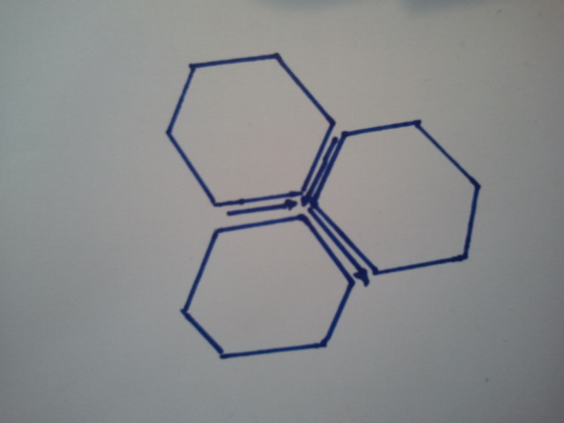
This emergency shelter can also help make a community as well. When all the houses are gone because of the flood, they can use my emergency shelter and use them as temporary houses. Also, because the shapes are the same the gaps between each of the hexagonal prism can make a street for the people to go through which makes the shapes more efficient. The shelters can also be used for entertainment and restaurants as well. If there will be a street, restaurants and other buildings such as banks, these shelters could also make an efficient temporary society. They can live in this temporary society while they rebuild their old one.
Bird’s eye view
The design enables the people using it to live where ever they want such as up on a high place or on ground level. That is why this emergency shelter can meet everyone’s needs. There are windows on four walls which enables the user to see what is going on outside in case of emergency.
Overall, emergency shelter model 2 is the ideal model that my client and I want and chose.

- Final Design Develop

Note: This shelter is almost the same except that there is a metal cylinder in the middle which holds up the ceiling. Also another different thing is that the metal is covered with waterproof material to prevent rusting. There is also no ladder.
The ceiling is made out of metal covered in a thin layer of waterproof material so that it doesn’t rust.

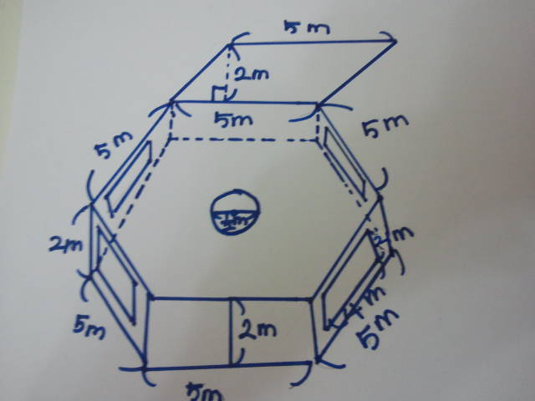
The windows are made out of waterproof material.
This is a metal cylinder which will hold the ceiling up.
The floor is made out of wood and has a carpet.
The windows are made out of waterproof material. The walls are made out of wood.
The door is made out of cloth material.

The floor is made out of wood and topped with carpet. The ceiling is made out of metal and is covered with waterproof material.
- Final Design

Flap that helps the shelter to stay in high places. Can be attached and detached.

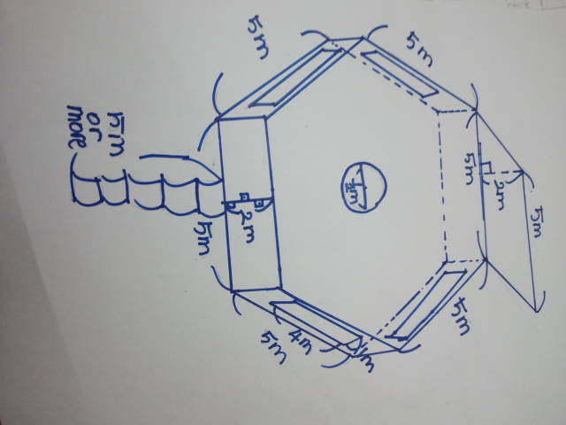

Metal cylinder to hold up the ceiling.

The windows are made out of waterproof material and the walls are made out of wood.
Ladder can be attached and detached.

Button up cloth doors.

Note: The two things that are different from the final design develop is that there is a ladder and that there is a button lock for the doors. If we have a button lock the cloth door it would be less dangerous even if we do have a ladder.

- Evaluate Final idea against specification

Target Market (2): I said that the target market for my emergency shelter was the people of China. The emergency shelter is made for the large populations. (2 out of 2)
Functions (1): The functions that the emergency shelter has to do are giving warmth and shelter. This emergency shelter gives both warmth, because of the carpet, and shelter because it is an emergency shelter. (1 out of 1)
Materials (2): The materials that I stated I had to use were wood, metal, waterproof material, and cloth. The ceiling is made out of waterproof material and metal, the floor is made of wood and carpet, and the window is made out of waterproof material. (2 out of 2)
Ergonomics/ overall sizes (2): I said that the overall size of the emergency shelter should be able to fit about 5-10 people. I think that because the shelter is big, it will be able to house about 5-10 people. (2 out of 2)
Manufacturing processes and quantity (1): I said that we probably will make about 1,050 emergency shelters. I think we need about that much shelters for the people of China. (1 out of 1)
Equipment/ tools- requirements (1): The tools that I said I needed were: Hack Saw, Coping saw, Steal rule, Snips, File, Engineer square, Pliers, Scissors, Screw driver, Hammer, Tenon saw, and a Craft knife. I think I will need all of these because I will need to cut and stick a variety of materials. (1 out of 1)
Maintenance Requirements (1): The maintenance requirements were that there shouldn’t be too much people in an emergency shelter because the shelter will break. I don’t think we need to overflow the emergency shelter because we have enough space. (1 out of 1)
Product life span and life cycle (1): I said that the emergency shelter should be reusable again. This shelter can be reused because it is not made so that it can decay. (1 out of 1)
Aesthetic appearance (Shape, color, texture) (2): I said that the shape of the emergency shelter should be a hexagonal prism and should have a translucent color. The windows are going to be a translucent color and the shape of the shelter is a hexagonal-prism. (2 out of 2)
Quality Assurance (1): I said that there will be a quality assurance. There will be a quality assurance. (1 out of 1)
Quality Control (1): I said that there is going to be a quality control. There is going to be a quality control. (1 out of 1)
Cost (2): I said that the cost has to be about 100 TL so that the people can afford to buy it. Both the client and I agree that this emergency shelter would cost about this much. (2 out of 2)
Time scale and planning (1): I said that the time scale would be about 48 minutes. Because this shelter is very simple and easy, it will take about this much time. (1 out of 1)
Health and safety (1): I said that the emergency shelter will be checked again and again to check if it is safe. There will be checks on that after we make the emergency shelter. (1 out of 1)
Overall score: 19 points

