Create (Step 4)
MYP Design Cycle

By Calvin Cakmak

My Process Journal
Date | 22nd November 2012
Number of days left | 19 days left
Work completed and tools used | I have cut the jelutong, and I have finished making the triangular piece of wood. I have asked Mr. Brian Thorburn to cut this piece of wood with a hand saw.
Problems | There were no problems.
Am I keeping to my plan of action? | Yes, I had to cut a triangular piece of wood, which was for the front of my shelter
What I need to do next | Next, will have to cut out two other pieces of ply wood, these will be used for the walls.

Date | 20th November 2012
Number of days left | 17 days left
Work completed and tools used | I have completed cutting the 3 jelutongs; I have used a hack saw to do this.
Problems | I did not have enough time, because it was a short period.
Am I keeping to my plan of action? | Yes, I was supposed to cut 3 jelutongs and glue them together, I am on track.
What I need to do next | I have to cut the last jelutong and start to cut the ply wood into a triangular shape.

Date | 22nd November 2012
Number of days left | 15 days left
Work completed and tools used | I have completed making the walls of my shelter. I have asked Mr. Brian Thorburn to cut this since it is really strong and hard to cut. He used a hand saw to do this.
Problems | The main problem was that when the 2 walls were cut I have seen that they were not the same size. I had found a solution and I decided to close the whole between the two with a piece of jelutong
Am I keeping to my plan of action? | Yes, I had to cut out 2 rectangular pieces of wood and stick these to the front of the shelter
What I need to do next | Next, I will have to cut out another triangular piece of wood which will be used for the back of my shelter.

Date | 27th November 2012.
Number of days left | 10 days left.
Work completed and tools used | I have completed drawing the shape on the wood, with a pencil.
Problems | This class was really really short, I could not do anything.
Am I keeping to my plan of action? | Yes, I am cutting out the last piece of triangular wood, and then I can start gluing the pieces together.
What I need to do next | Next, I will have to ask Mr. Brian Thorburn if he could cut out the triangular piece of wood.

Date | 30th November 2012.
Number of days left | 7 days left.
Work completed and tools used | I have completed cutting the triangular piece of wood, and cutting the high density foam board. Then I cut out a bit out of the triangular piece and put the high density foam board in. I used a glue gun to do this
Problems | The biggest problem was that the hole cut through my triangular piece of wood. Was too big, but I fixed this by putting extra glue on it.
Am I keeping to my plan of action? | Well, I have changed a bit of my plan. I was supposed to have 1 triangular piece of wood, and 3 rectangular pieces. But since that did not really fit I decided to cut another triangle instead of a rectangle, to make my shelter better.
What I need to do next | Next, I will have to glue all the pieces together with a glue gun. I have to be careful not to touch it, or else my hand will burn.
Date | 4h December 2012.
Number of days left | 3 days left.
Work completed and tools used | I have completed gluing the triangular piece of wood, to the rectangular piece of wood, I have used a glue gun to do this
Problems | A little problem was that I burned myself using the glue, I have to be more careful
Am I keeping to my plan of action? | Yes I am, I glued the pieces together as written in my plan.
What I need to do next | Next, I will have to glue the 2 rectangular pieces of wood with the triangular pieces.

Date | 4th December 2012.
Number of days left | 3 days left.
Work completed and tools used | I have completed gluing all the pieces together, again I have used a glue gun to do this. I have also completed putting the structure stick onto my model.
Problems | No problems occured
Am I keeping to my plan of action? | Yes, I glued the pieces together as written in my plan.
What I need to do next | Nothing, I have completed my model, and step 4 Create
This is the end of my Process Journal

Pictures made during making the model:
1: Drawing it on wood
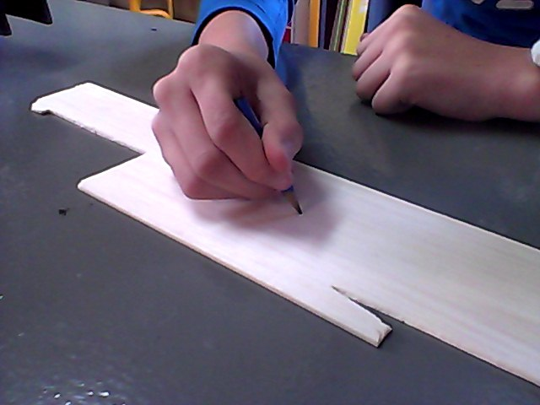
In this picture I am drawing on a piece of wood. This piece of wood is called ply wood. This drawing helps me cut this wood better, and makes it more accurate. This will be used for the front of the shelter.
2: Gluing structure sticks:
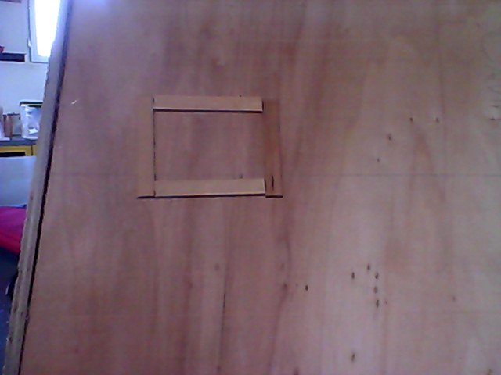
Here I have glued the structure sticks on my model. This is supposed to be a “window” while gluing this I burned my finger, unfortunately I do not have a picture of that

3: Final Model
In this picture you can see that I have completed making my final model. There is a door in the middle of the shelter with structure sticks glued onto them. The changes I have mad are that this is not a pyramid but in a kind of a tent shape.

Linking specification to my model
Time scale and planning
Like said in my specification it took me 2 weeks to build this model. It included, sketching, drawing, gluing and final bits.
Quality Control
As you can see the sides on the wood are all curved smoothly and nothing sharp is sticking out of it

Materials/ tools used
I have almost used all of the materials/tools listed in my specification. I have used these materials and tools really carefully, nothing broke.

Functions
The function of this emergency shelter is to be safe from earthquakes. I think this shelter is available to do this

Evaluation
In this step of the MYP design cycle I have had a lot of fun. This is especially because we have been building our model after investigating, designing it, and planning it out. I have put a lot of effort in my work, model, and A4 presentation. I did not build my model really precisely but I am very proud of what I have done.
I think that building my model is built really well. During building my model, I have encountered some problems. One of the biggest problems was that one rectangular shape of wood was way too big, and one was too small. I solved this problem by putting a lot of glue on top of these 2, and they fitted perfectly together. I have realized that in my plan it said needed to build something on top of the shelter. I have decided that this is unnecessarily. Another problem was that when I put glue on my model, it directly went hard, so I had to do it very fast. Other than that, my model has been built following my design and plan. In my design it does look like a pyramid, but I had to make it into a straight line.

