Step 4: Create (Process Journal, evaluation, and Link in to Specification)

Name: Halim Kim Class: 7S3 Teacher: Mr. Thorburn

- Process Journal

Date | November 20, 2012
Numbers of Periods left | 7
Works completed a tools used | I am half way on making my ladder which is step 5. The materials I used are the thick rope and the match sticks. The tool that I used is the scissor. I used the hack saw, the scissor, and the sander.
Problems | The problems of today where that I stated that in step 4 I should only use 3 pieces of 200 mm long rope but it turned out that it was such a small amount. So I got more pieces of rope to use for tying the match sticks. For it to be more stable, I will glue gun the joints of the ladder.
Am I keeping to my plan of action? | I am putting my plan of action. However the making of the ladder took more than 20 minutes so I might have to manage the time a little bit.
What I need to do next | I need to finish off my ladder and then make the floor of my emergency shelter.

Date | November 20, 2012
Numbers of Periods left | 6
Works completed a tools used | I completed cutting the ceiling the walls, the slip at the back, and the ceiling holder. I used the hacksaw, scissor, and the craft knife.
Problems | Because I changed the hexagons size the sides were all different but close in length together. I had to make the walls to match that and the height was too tall so I made it 100mm. I also changed the material to Corrigated Art sheet that is used for the ceiling because the other material was not able to cut in to a hexagon. The measurements of the ceiling changed as well because the floor’s measurements are different. The slip at the back was also adjusted so that the length was the same as the length of the wall it is stuck on.
Am I keeping to my plan of action? | Yes I am, but I need to be careful when cutting. Measure twice, cut once.
What I need to do next | I need to finish cutting, specifically the plastic sheet used to put on the ceiling.

Date | November 27, 2012
Numbers of Periods left | 5
Works completed a tools used | I completed cutting the carpet out of thick cloth and cut out the hole in the middle. Used a scissor for this process.
Problems | There are no problems. However, I have a big problem coming up ahead which is cutting out the walls to make windows in them.
Am I keeping to my plan of action? | Yes I am, keeping my plan of action up to date.
What I need to do next | I need to finish cutting, specifically the plastic sheet used to put on the ceiling and the windows in the walls.

Date | November 27, 2012
Numbers of Periods left | 4
Works completed a tools used | I completed cutting the carpet out of thick cloth and cut out the hole in the middle. Used a scissor for this process.
Problems | There are no problems. However, I have a big problem coming up ahead which is cutting out the walls to make windows in them.
Am I keeping to my plan of action? | Yes I am, keeping my plan of action up to date.
What I need to do next | I need to finish cutting, specifically the plastic sheet used to put on the ceiling and the windows in the walls.

Date | November 29, 2012
Numbers of Periods left | 3
Works completed a tools used | I cut out the window pieces and the ceiling sheet with the plastic sheet. The tools I used for this was the craft knife. I also filed the walls up by using a file.
Problems | There are no problems. However, the deadline is coming up and I have to work quickly.
Am I keeping to my plan of action? | Yes I am, keeping my plan of action up to date. However, I changed some things. Instead of cutting a square inside the walls for the window, I just stuck plastic sheets to represent windows.
What I need to do next | I need to glue my model together.

Date | November 30, 2012
Numbers of Periods left | 2
Works completed a tools used | I glue gunned half of my model. The tools used are the glue gun.
Problems | There are no problems. However half of the periods that we can use are finished so I need to make my model as quickly as possible.
Am I keeping to my plan of action? | Yes I am, keeping my plan of action up to date. I will try to finish my model the next class.
What I need to do next | I need to finish my model by glue-gunning the rest of my model together.

Date | December 4th 2012
Numbers of Periods left | 1
Works completed a tools used | Gluing and cutting the flap and filing it.
Problems | I had no major problems. There is one minor problem which was that there are gaps between the walls. I fixed this problem easily because I glue gunned the sides that were empty.
Am I keeping to my plan of action? | Yes I am keeping my plan of action because now I only have to do the finishing touches. I have Oliver Twist so I have one last period to finish up my model.
What I need to do next | I need to make the flap and the door of my emergency shelter.

Date | December 4th 2012
Numbers of Periods left | 0
Works completed a tools used | I made my flap and glued it to my shelter model. I also made the door with some string and cloth. The tools used are the craft knife, file, and the glue gun.
Problems | I had no problems except I changed the design a bit so that the door could be held up. Also I reduced the height of the flap because the width was over 300mm.
Am I keeping to my plan of action? | Yes I am keeping my plan of action. I am planning to come in break time to take pictures of my model.
What I need to do next | Take pictures of my model so that it is clear.

- Evaluation
Overall, I did a good job building my model. Something I had in mind and was worried about was the case that I had Oliver Twist and was going to miss Thursday and Friday. I finished my model quickly and made some time to do the evaluation at the end. I couldn’t follow my plan step by step because we had to cut out the things before we glued them. I didn’t expect that change of plan.
I also made several changes here they are listed:
- Change of Ladder: I changed the number of matchsticks and the length of the ladder because the space between them was too small.

- Change of the hexagon size: I changed it so that the hexagon across was 200mm because if I did each side 200 mm it would be over the size limit.

- Change of the ceiling material: I changed the ceiling material from hard density foam board to a blue corrigated art sheet because the high density foam board wouldn’t cut properly.

- Change of the door lock: I changed the door lock so that the door goes up on either side because it will be more organized then having buttons.

The good things that I did about my create stage is that I did the process journal right after I built my model which brought back memories much faster so I was able to write more. Overall the model looks very much like my design.
I took my process pictures in the time that they are supposed to be. One in the beginning, one in the middle, and one at the end.
The link in to the specification was fine and I had a lot of points that I could link in to my model. One point that was different from my specification was:
- It is supposed to be transparent but it is not.
That was the only point that could not be linked in. Despite the obstacles in building my model, the overall process was a smooth road.

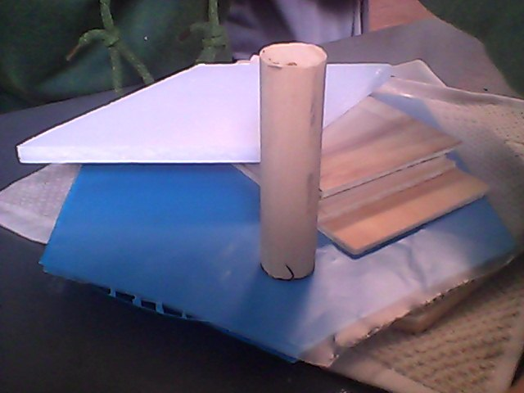
- Link in to Specification

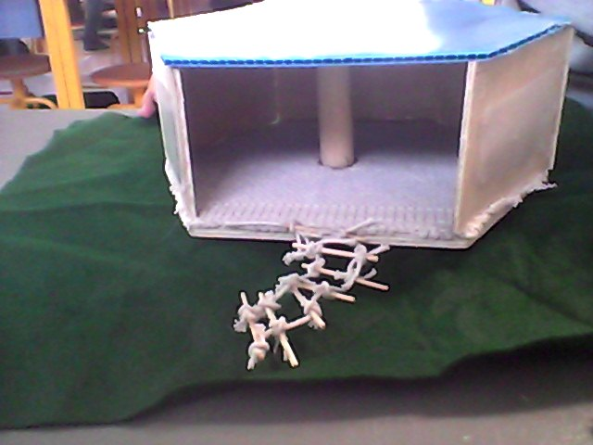
Metal (Corrigated art sheet)
giving them warmth. (carpet)

Waterproof material (plastic sheet)
Wood
The shape of this shelter is going to be a hexagonal prism.

Next page

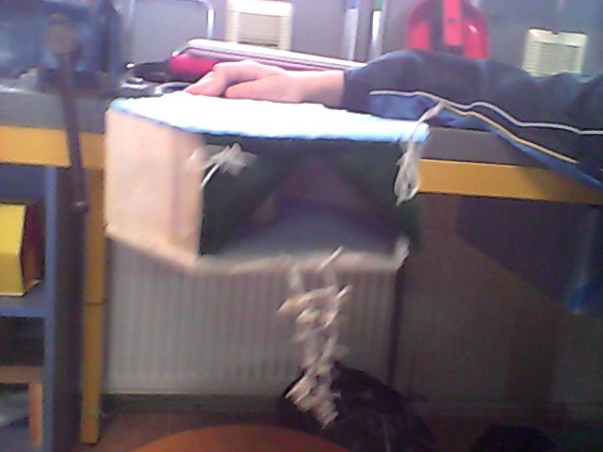
To check that my emergency shelter is safe we will check its stability after it is made numerous times. (putting strength; not falling)
Cloth material

